Date……………………………………………….
L.O: To write a caption for a picture in a newspaper article.

Write a caption that links to each picture

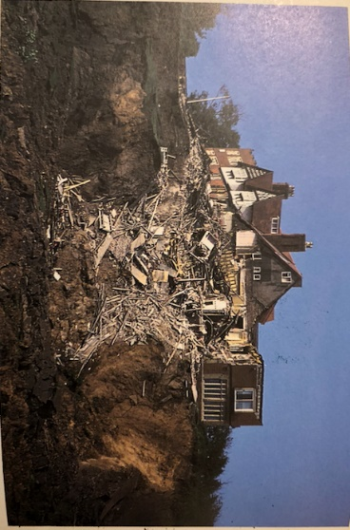

Caption:

Caption:



Caption
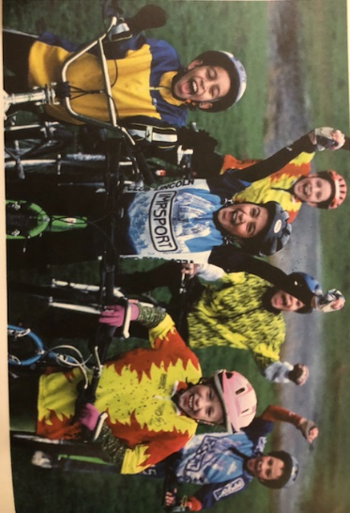

Caption:

