Date……………………………………………….
L.O: To write a caption for a picture in a newspaper article.

Write a Headline and a caption that links to each picture
Headline:

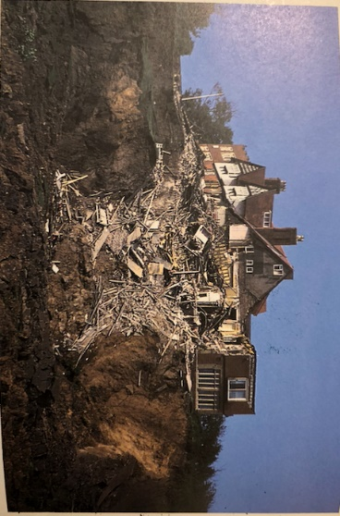
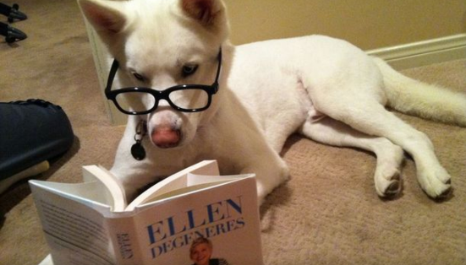
Caption:

Headline:

Caption:


Headline:

Caption
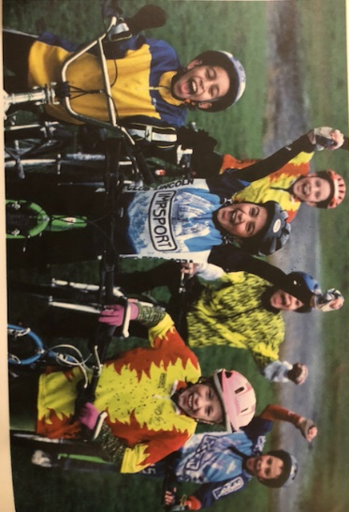

Headline:

Caption:

