Newspapers opening papragraph Lewis
Date:
LO: To write an opening paragraph for an article based on the picture.
Look at the headline and the picture. Think about what the article would contain. Write an opening paragraph for your story.
Genius Inventor Discovers New Way To Travel!

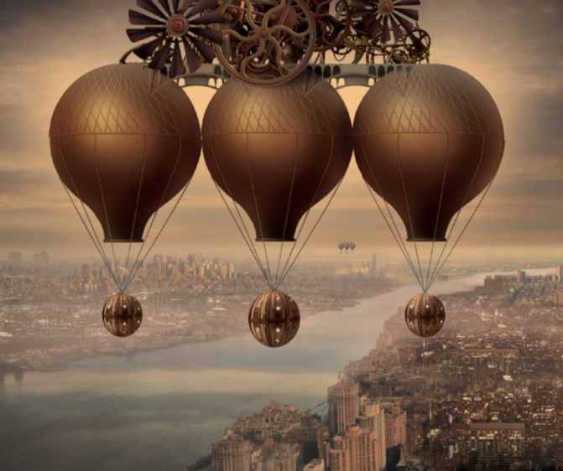

Newspapers opening papragraph Lewis
Date:
LO: To write an opening paragraph for an article based on the picture.
Look at the headline and the picture. Think about what the article would contain. Write an opening paragraph for your story.
Genius Inventor Discovers New Way To Travel!


