

Welcome to Year 2!
We are really excited to welcome you to our Year 2 Bubble in September! In our year group there will be Mrs Lamb, Mrs Parsons and Mrs Owen. You may also be supported by Mrs Pritchard and Miss Rylands.
You will continue to have your own work pack filled with all the stationery you’ll need and will sit at a desk facing the front of the classroom. Please wear your winter uniform to school. PE will be on Wednesdays and Thursdays so please come to school in your PE kit on those days (including blue jogging bottoms and blue jumpers/hoodies when it’s cold). White or black trainers suitable for sport NOT fashion may be worn. You are not allowed to wear jewellery for PE (including earrings) so please make sure you have removed these before you come to school.
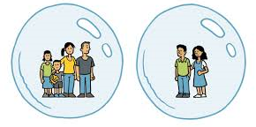
Our Year 2 Bubble will learn, play and eat together.
What to bring to our bubble
- Named water bottle
- Labelled Sunhat (if the weather is still nice)
- Labelled coat
- Named “own” soap / moisturiser for chapped hands (only if you wish)
- A piece of fruit or small pot/bag of fruit.
- A book bag

What not to bring
- Cuddly teddies
- Toys from home
- Pencil cases

You will come in to, and out of, our bubble through the Year 2 door.
On arrival at school
- Keep a 2m distance from other parents and children
- Maintain 2m distance from the teacher on the door
- Go to peg, hang up coat
- Place water bottle and fruit snack on your desk
- Immediately wash hands

You will be coming in to school at slightly different times to some of your friends so here is our list – you need to find the first letter of your last name to work out what time you will come to school.

Start (KS1)
8.45: A -F 8.50: G - M 8.55: N - Z All Finish 3.15 pm
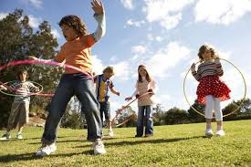
We will be having one morning playtime and lunch time. Mrs Day will be looking after you at lunch time and you will go out to play first from 12.00- 12.30pm, and then eat lunch in the classroom.

Our new school Christian value for Autumn term is Friendship, which will be a really lovely start to our new school year. Remember if you have any worries there are always lots of people you can talk to.
Homework will be given out on a Thursday, due in the following Monday. Spellings will be tested on a Friday.
I am sure you have been looking at the ‘Covid summer catch up’ page on the Year 1 class web page- if not then take a look. There are some fun activities on there to get your brains working again before the start of school. Also, please don’t forget your logins for the computers, Purple Mash, and Times Tables Rockstars as we will be using these lots more in September! We will also be using email to contact your families, although we will only reply in office hours to make sure we all get a break from technology!
lambn@sps.sefton.school
parsonsh@sps.sefton.school
Enjoy the rest of the holidays and we can’t wait to see you next week!
Love, The Year 2 team



