
Friday 3.4.20

English tasks for the day:
Spellings Keep practising - Spring 2, week 5
Phonics Start your learning with some phonics fun
Purple Mash activity to practise sounds you have learnt before
– ir, ur
SPaG – Punctuation.
- Purple Mash – complete Purple Mash activity – Little Red Meets a Wolf

Comprehension
Please choose the comprehension best suited for your reading level.
- Read the passage
- Answer the questions

Reading I wonder what will happen in the next chapter
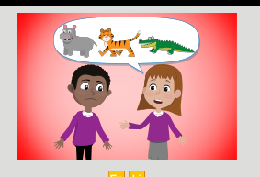
Serial Mash – Ned and the Jungle animals.
Read chapter 3 and complete the short, fun activities about the chapter you have read.

