The Fish Who Could Wish
Tuesday 23rd June
LO. To write in complete sentences hat you would wish for and why.
LO. To write full sentences using the correct punctuation.
The Fish Who Could Wish did not realise how lucky he was and made a very silly mistake.
If you could have whatever you wished for, what would you choose?
Would it be for you or your family or friends?
Why would you wish for these things?
What are the things you would wish for?

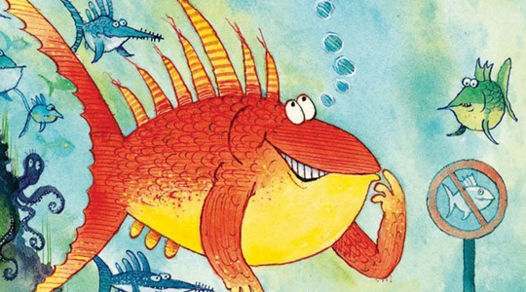
___________________________________________________________________________________________________
___________________________________________________________________________________________________
___________________________________________________________________________________________________
___________________________________________________________________________________________________
___________________________________________________________________________________________________
__________________________________________________________________________________________________
Check your punctuation.
Think about the following punctuation. Have you used it correctly?
- Capital letters
- full stops
- exclamation marks
- question marks
- commas

