The Whale and the snail
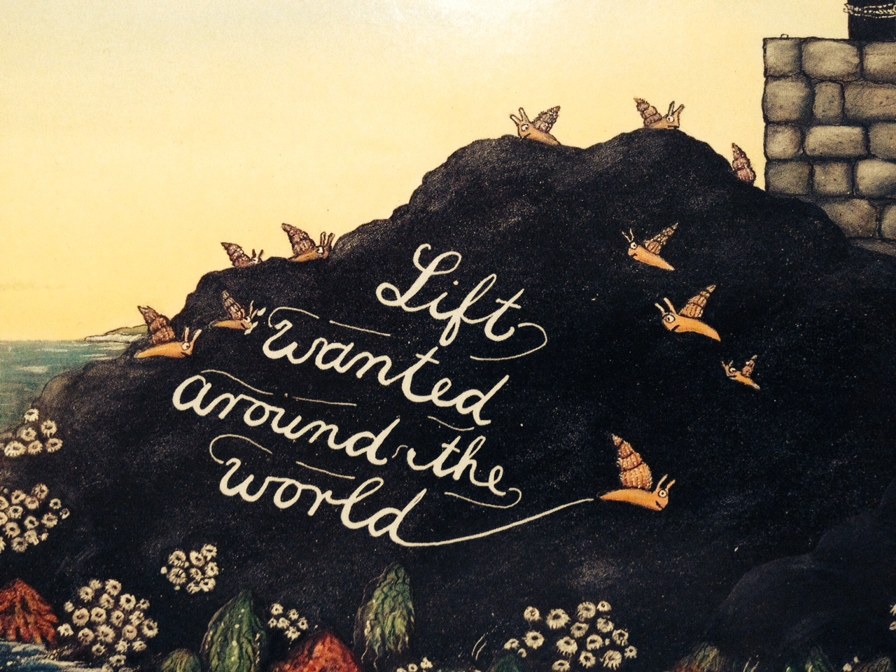
Wednesday 1st July
LO: To describe how the snail is
feeling using adjectives
Re-watch yesterday’s video clip that shows how the little snail is feeling. Using interesting adjectives (describing words) write a paragraph to describe the snail’s feelings, dreams and wishes.
In the first clip, the little snail _________________________________________________________
______________________________________________________________________________________________________
______________________________________________________________________________________________________
______________________________________________________________________________________________________
Now, watch today’s clip that shows us
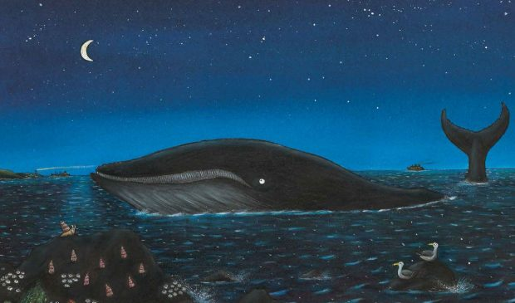
how the whale meets the snail and takes
him off on a journey. Describe the little
snail’s feelings. Have they changed?
What new words will you use?
In this clip, the little snail ______________________________________________________________
______________________________________________________________________________________________________
______________________________________________________________________________________________________
______________________________________________________________________________________________________
Now write out as many adjectives that you can think of to describe the sea, including harbours and beaches. I have started you off with some adjectives.
magnificent calm busy dangerous
________________ ________________ ________________ __________________
________________ ________________ ________________ __________________
________________ ________________ ________________ __________________
________________ ________________ ________________ __________________

