The Snail and the whale
Thursday 2nd July
LO. To find all the adjectives and verbs in a text.
Underline all the adjectives and verbs using a different colour for each.
Then write them out in two lists to practise your handwriting and spelling.
There are 10 adjectives & 8 verbs to find.
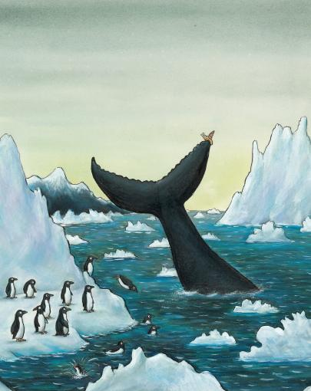

This is the sea,
So wild and free,
That carried the whale
And the snail on his tail.
To towering icebergs and far-off lands.
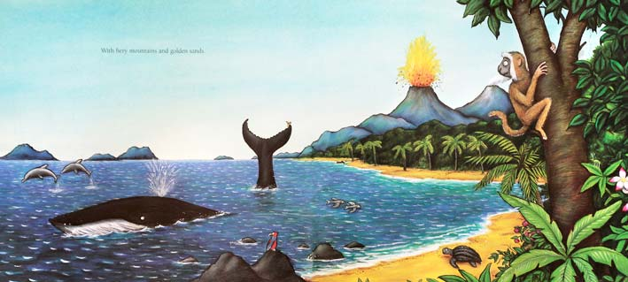

With fiery mountains and golden sands.

These are the waves that arched and crashed,
That foamed and frolicked and sprayed
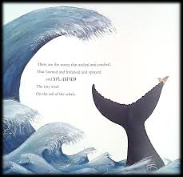
And splashed
The tiny snail
On the tail of the whale.

These are the caves
Beneath the waves,
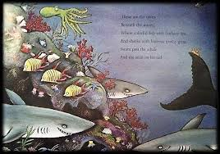
Where stripy fish with feathery fins
And sharks with hideous toothy grins
Swam round the whale
And snail on his tail.

