The Snail and the Whale
Tuesday 7th July
LO. To find evidence in a story to show understanding.
During our story so far, the whale has shown the snail some amazing things, beautiful and glorious things. (adjectives)
However, there have been some scary moments! Can you remember what these dangers were and the problems they met?
Look at the pictures below and write a descriptive sentence about each danger or problem they had to face at each stage of the story.
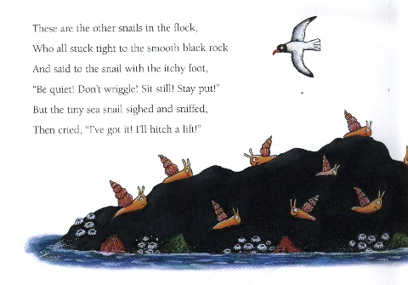 Black rocks
___________________________________________________________________________________________________
___________________________________________________________________________________________________
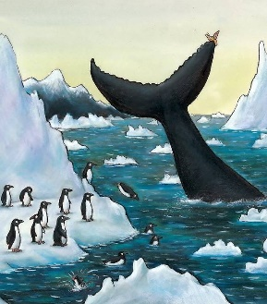 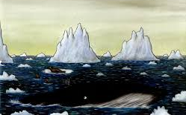 The icebergs
___________________________________________________________________________________________________
___________________________________________________________________________________________________
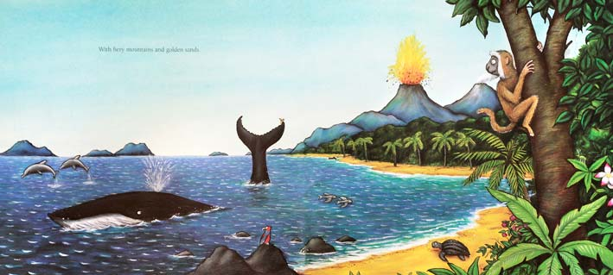 Fiery mountains
___________________________________________________________________________________________________
___________________________________________________________________________________________________
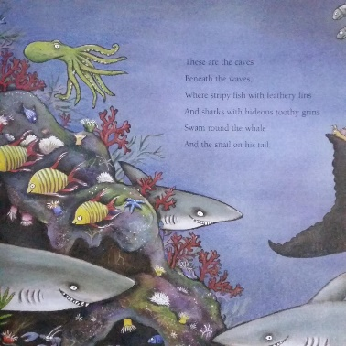 Caves beneath the waves
___________________________________________________________________________________________________
___________________________________________________________________________________________________
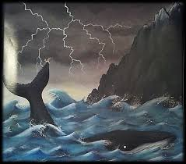 The storm
___________________________________________________________________________________________________
___________________________________________________________________________________________________
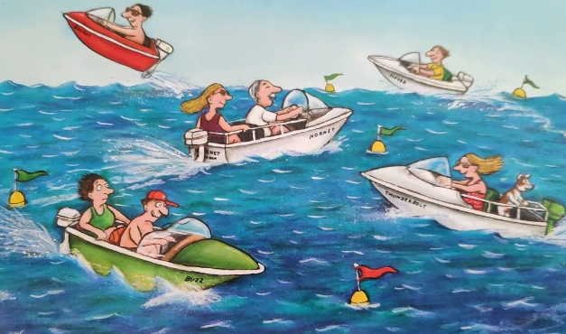 The speedboats in the sea
___________________________________________________________________________________________________
___________________________________________________________________________________________________
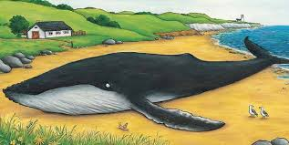 Stranded on the beach
___________________________________________________________________________________________________
___________________________________________________________________________________________________
What does the snail do now?

