Tiddler -Oral Comprehension
Monday 13th July
LO: To find answers from a story being read aloud.

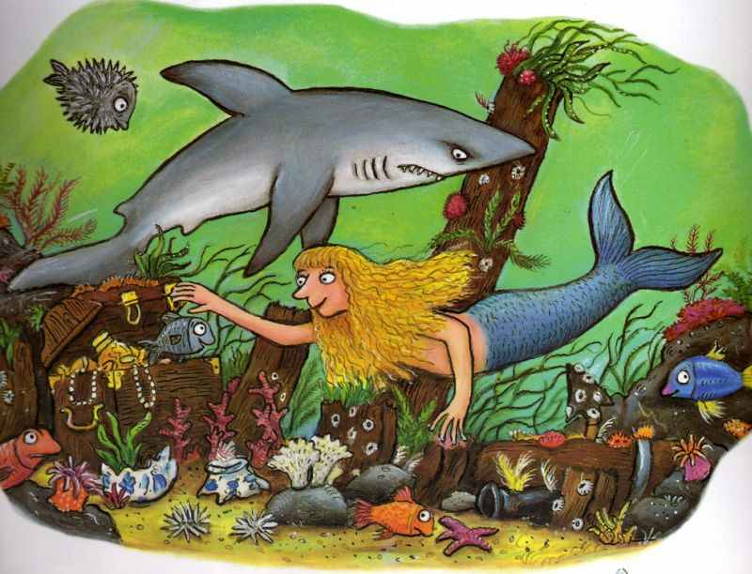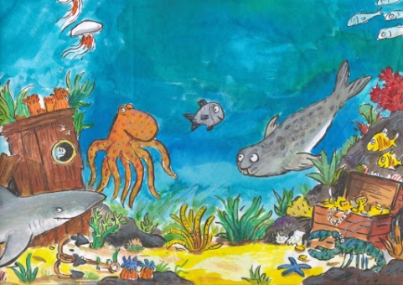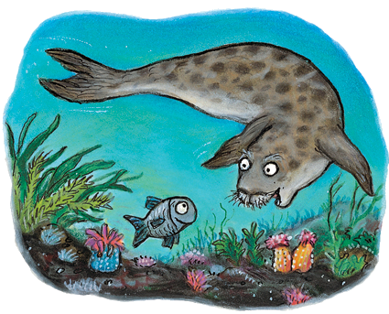

Listen to the video of the story and answer these questions.
Read the questions before listening to the story
You may have to pause the story to give you time to write the answers.

- What time should Tiddler be at school for?
__________________________________________________________________________________
- Who did he say had rescued him from the treasure chest?
__________________________________________________________________________________
- Which sea creature did he say had captured him?
__________________________________________________________________________________
- Tiddler is lost in the ocean; how do you think he feels?
__________________________________________________________________________________
- Where did Tiddler hide?
__________________________________________________________________________________
- Who does the starfish tell Tiddler’s story to?
__________________________________________________________________________________
- Who recognised tiddler’s face?
__________________________________________________________________________________
- Why don’t Tiddler’s friends believe him? Do you believe him?
__________________________________________________________________________________
- Name two of Tiddler’s friends.
__________________________________________________________________________________
- Have you ever tried to get out of trouble by making up a story? If yes, what happened?
________________________________________________________________________________________________________________________________________________________________________
____________________________________________________________________________________

