Tiddler – Fact or opinion
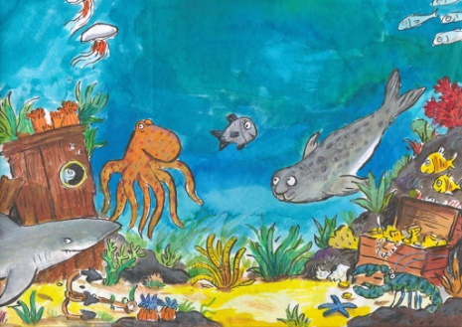
Thursday 16th July
LO: To identify which statements
are fact and which are an opinion.

- Read the following statements about the story of ‘Tiddler’.
Some of these are facts, others are someone’s opinion.
- Write fact or opinion next to each statement. Like this;
Tiddler’s stories were silly opinion
Tiddler got lost in the ocean
The fishermen should not have thrown Tiddler back into the ocean
Tiddler got caught in a net
Tiddler was a grey fish
Everyone should go to school
Little Jonny Dory has a granny
Tiddler was always late
The other fish were unkind
- The author uses 'meanwhile' as a time connective. Can you find out any others?
____________________ ____________________ ______________________
____________________ ____________________ ______________________
- Can you think of any adjectives to describe Tiddler?
____________________ ____________________ ______________________
____________________ ____________________ ______________________

