L’Animalerie - The Pet Shop
mardi vingt-trois juin – Tuesday 23rd June
LO. To learn new vocabulary for pets.
Copy and complete these sentences using these words to help you.
J’ai = I have un = 1 deux = 2 trois = 3
et = and quatre = 4 cinq = 5
Can you add akl the missing words?

- J’ai

_______________________________________________________________________
- J’ai et
______________________________________________________________________________
- J’ai et
______________________________________________________________________________
- ? et
______________________________________________________________________________
- , 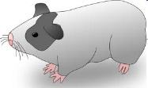 et
______________________________________________________________________________

