8th June 2021 STARTER
LO: What have the following sentences got in common?

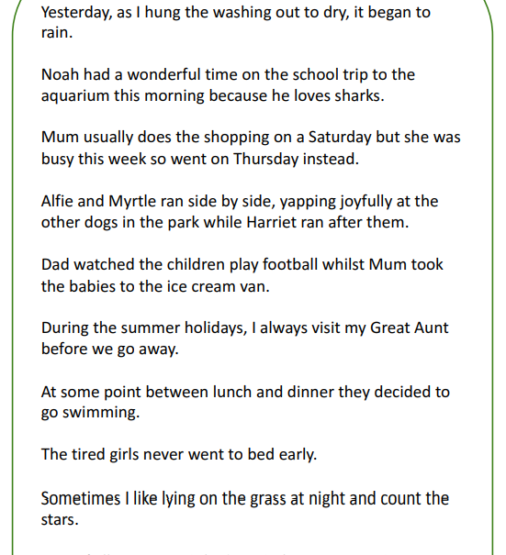

8th June Main Task
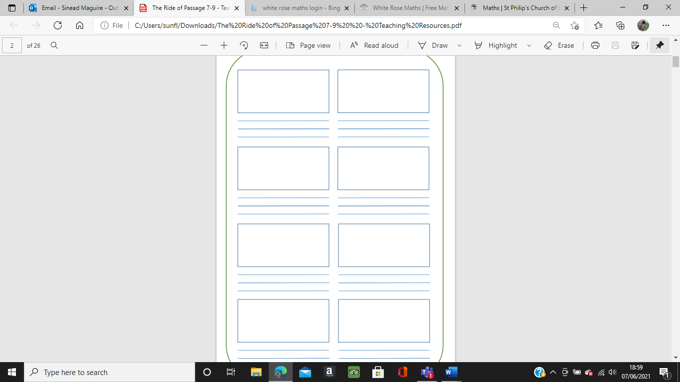
LO: I am learning to show passage of time and to order events using conjunctives and adverbial phrases. Children create a story board to demonstrate their understanding.

