



Hello Parents, Carers and boys and girls about to start Year 3!
Welcome to year 3; the first of the Junior classes. We are really excited to welcome you to our Year 3 Bubble in September! We’re going to call ourselves the “Sunshine Bubble”. In our sunny bubble will be Mrs Maguire, Mrs Westby, Mrs Edwards and Mrs Piper.
In our bubble you will be given your own work pack filled with all the stationery you’ll need and will sit at desks in rows, spaced out and facing the front of the classroom. Please wear your winter uniform to school, PE will be on Tuesday and Friday so please come to school in your PE kit that day (including blue jogging bottoms and blue jumpers/hoodies when it’s cold). Earrings are to be taken out prior to coming to school on PE days.
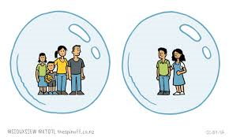
Our Year 3 Sunshine Bubble will learn, play and eat together.
What to bring to our bubble
- Named water bottle
- Labelled Sunhat (if the weather is still nice)
- Labelled coat
- Named “own” soap / moisturiser for chapped hands (if you wish)
- A small pot/bag of fruit which has been labelled to have as a mid-morning snack
- Your inhaler if you use one
- School bag

What not to bring
- Cuddly teddies
- Toys from home
- Pencil cases

You will come in to, and out of, our bubble through the Junior playground door.
On arrival at school
- Keep a 2m distance from other parents and children
- Maintain 2m distance from the teacher on the door
- Go to peg, hang up coat
- Place water bottle and fruit snack on your desk
- Immediately wash hands

You will be coming in to school at slightly different times to some of your friends so here is our list – you need to find the first letter of your last name to work out what time you will come to school.

Start Year 3
8.45: A -F 8.50: G - M 8.55: N - Z
Year 3 finish earlier at 3:15pm to reduce congestion at the door.

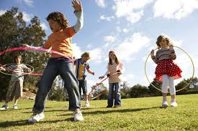
We will be having one morning playtime and lunch time. Mrs Piper will be looking after you at lunch time. You will eat lunch in the classroom first and then you will go out to play from 12.30- 1pm

Our new school Christian value for Autumn term is Friendship, which will be a really lovely start to our new school year. Remember if you have any worries there are always lots of people you can talk to.
- Homework will be given out on a Friday, due in the following Wednesday.
- Spellings will be tested on a Friday morning.
- Mrs. Klaassen will be teaching you on Friday afternoons.

Don’t forget the ‘Covid summer catch up’ page on the Year 2 class web page- there are some fun activities on there to keep your brains active right up until we start back on Thursday 3rd September!
Have a wonderful last week of the summer holidays,
See you all bouncing into our “Sunshine Bubble” on Thursday 3rd September.
Mrs. Maguire, Mrs. Westby, Mrs Edwards and Mrs. Piper.



