

Dear Parents and Carers,
This is your child’s homework book.
It will be sent home every other weekend with English or Topic homework to be completed. In order for it to be marked and quarantined please return on Monday of the following week if possible – but no later than Wednesday.
Spellings
There are some statutory spellings that the children need to know in Years 3 and 4. Please find a list of them below. Additional dojos will be awarded for extra spelling practise. Learning spellings doesn’t have to be boring; in fact, it can be great fun. See overleaf for some great spelling practise ideas.
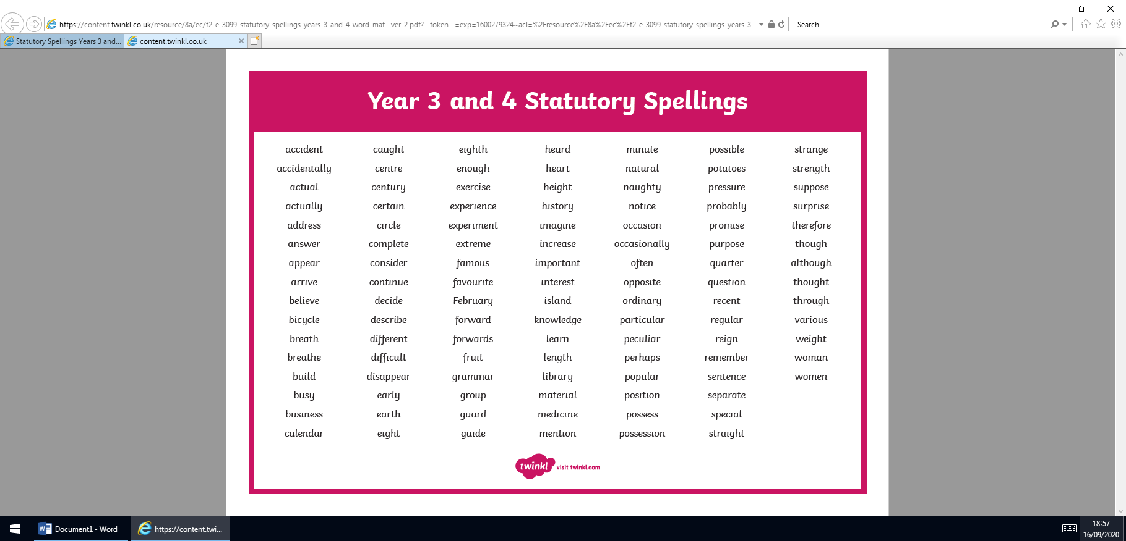
Many thanks, Mrs. Maguire and the Year 3 Team

