

Enterprise brainstorm
Week commencing 14th October 2019

What products/services can you think of that we could sell on enterprise day? Fill in your ideas on the brainstorm!

What problems do you think you might face this week? Things going wrong. People not working hard.
What Christian values might you need to use? Perseverance

Marshmallow pops
Sweet kebabs
What skills will your team need to use this week?
Good listener
Work as a team
Rocky road
Sundae
Rice crispie cakes

Sweets in a cone
Chocolate rocks
Chocolate bananas
Strawberries dipped in chocolate
Pick and mix
Cornflake cakes
Chocolate fruit


Enterprise week
2019
Who Wants to be an Entrepreneur?
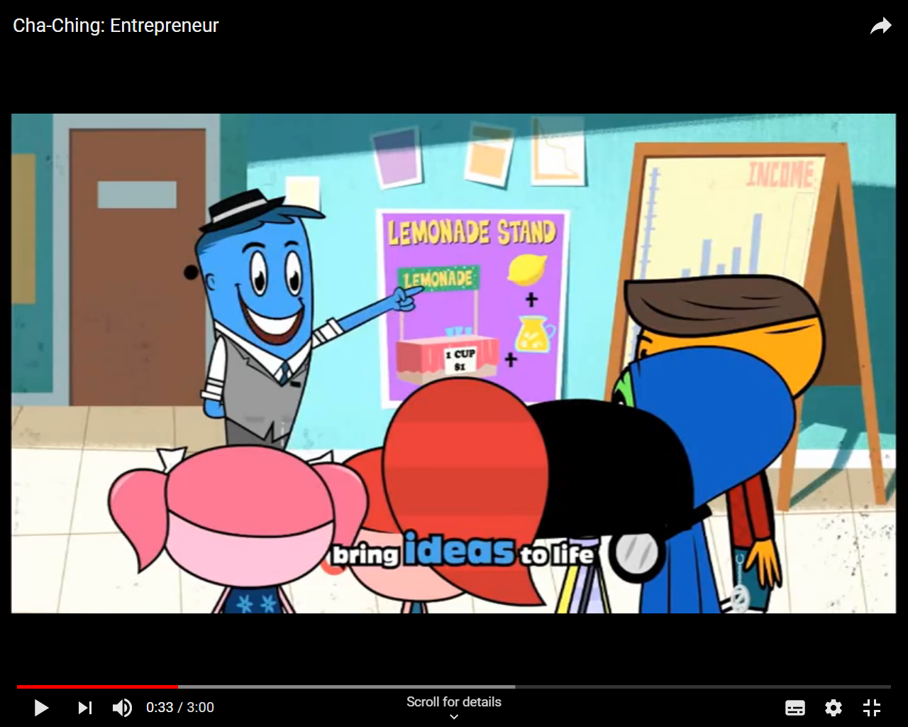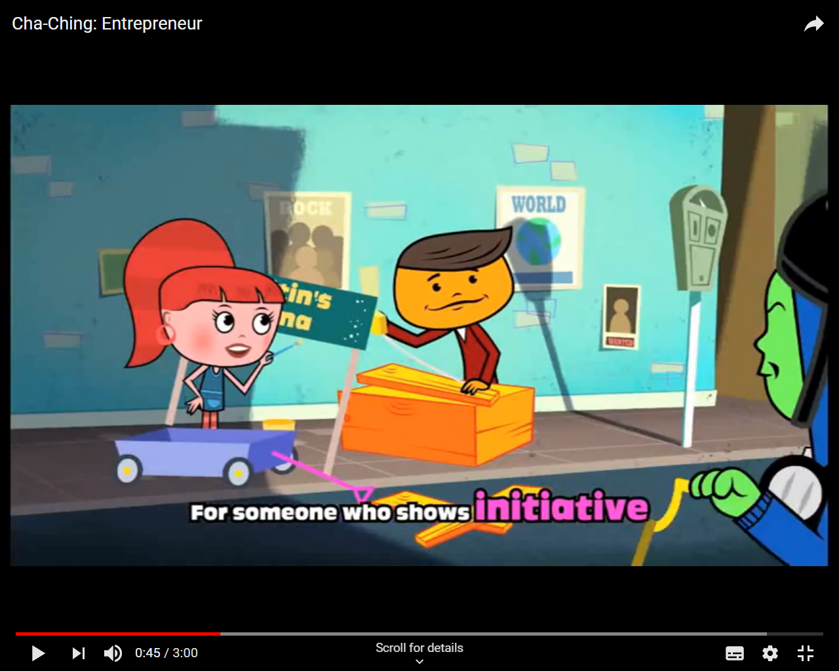

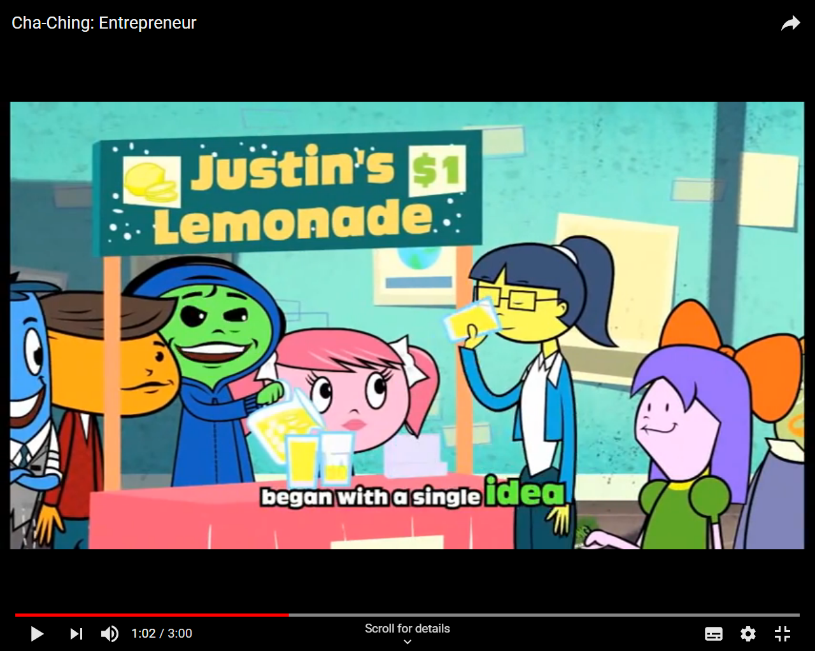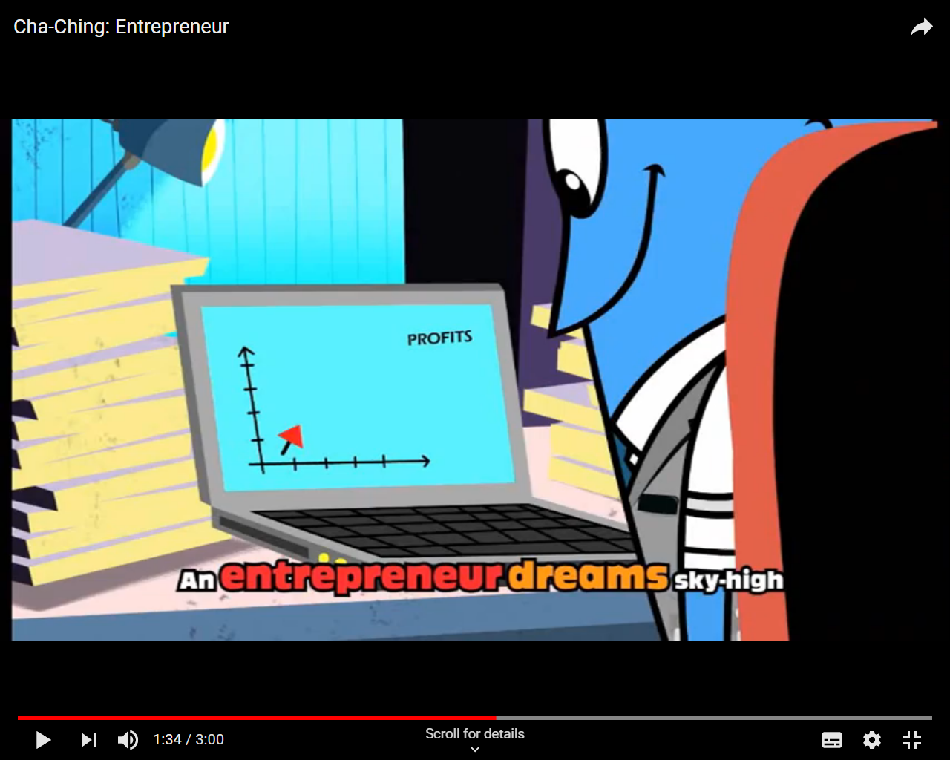

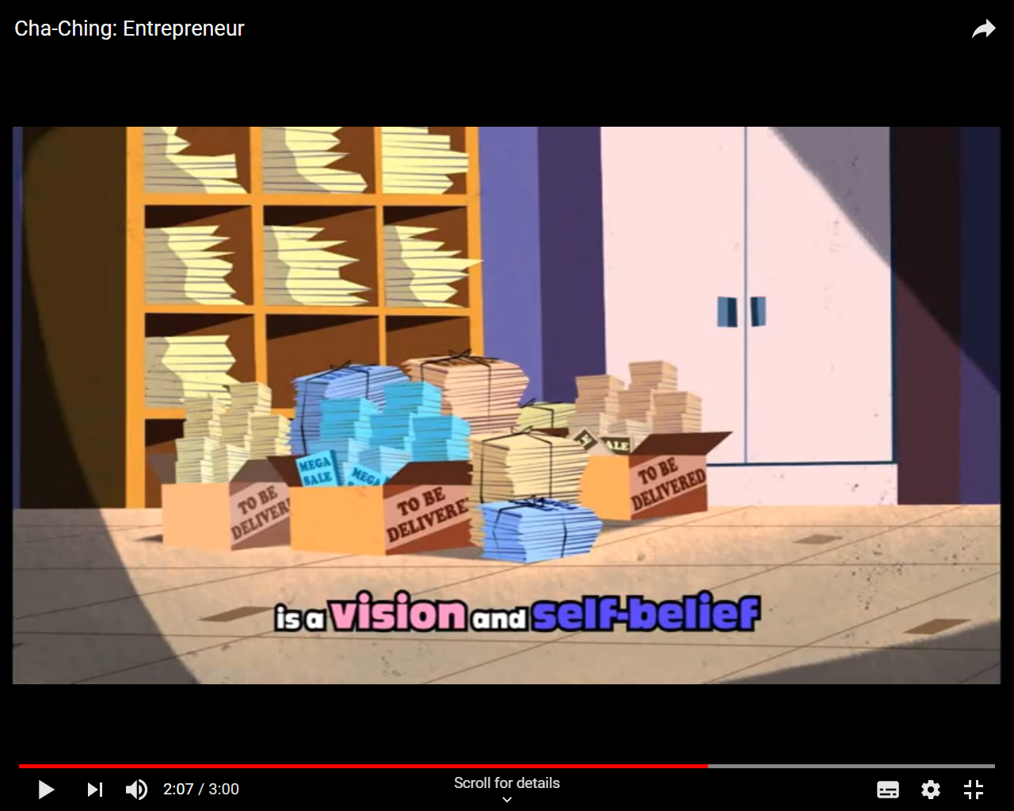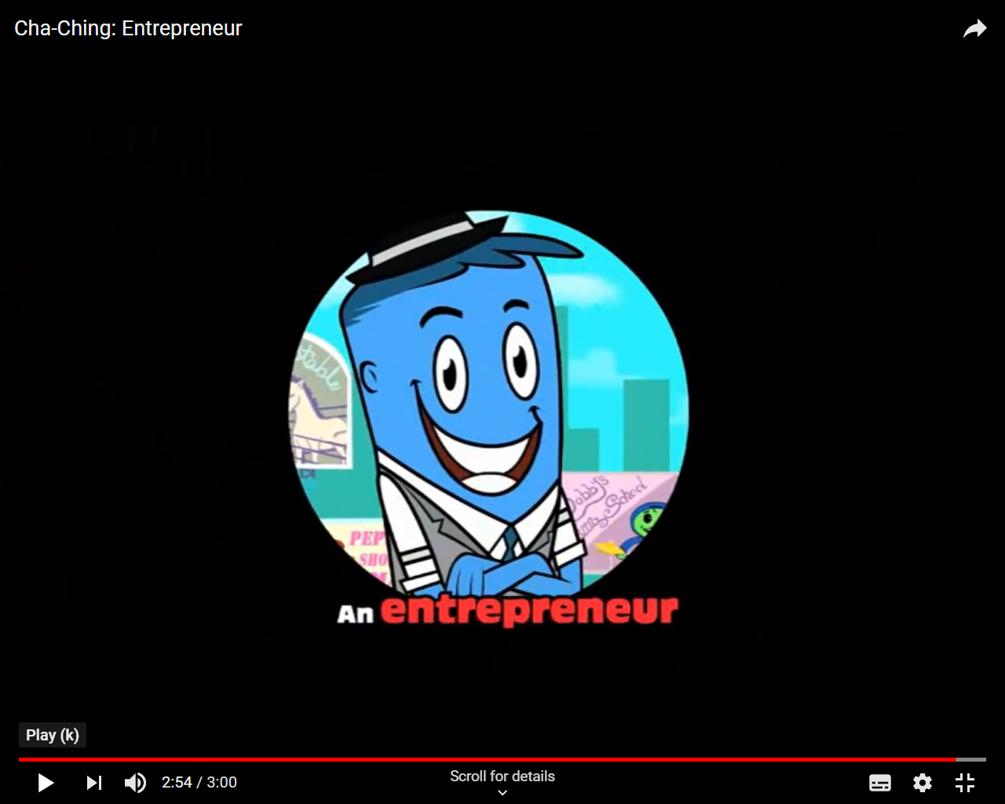

Evaluating our ideas

Ideas

What resources might we need?
Ingredients for the food – ice cream cones, sweets, chocolate for melting, cereal, marshmallows, kebab sticks

Are they expensive? (Estimate cost)
The ingredients will stick within £20 budget

Where can we access the materials/resource we would need?
The supermarket

How much could we sell it for? 50p - £1

Will the product make a profit? – Yes, because there will be more than 40 available

Is it something people would buy? – Yes, people always want sugary treats

Would we be able to market it and how? – colourful posters, persuasive language

Feasibility and Market Research

Now we've narrowed down our ideas, we need to understand whether these are 'feasible' (possible and practical) and something other children would want to spend money on.

List of materials/resources | Where they can be sourced from. | How many you need | How much they cost £
Chocolate | Aldi | About 13 blocks | 3.90
Strawberries | Aldi | One big box | 2.49
Marshmallows big | Aldi | One bag | 0.69
Marshmallows small | Aldi | One bag | 0.85
Sweets | Aldi | 6 varieties | 4.18
Cones | Aldi | One box of 10 | 0.85
Bags | Poundstretcher | 3 packs of tubs | 2.07
Sprinkles | Aldi | One pack | 0.85
biscuits | Aldi | 600g | 0.62
syrup | Aldi | One jar | 0.99
Rice crispies | Aldi | One box | 0.75
Margarine | Aldi | One tub | 0.69
Greaseproof paper | Poundstretcher | One roll | 0.90
 |  | TOTAL: | 19.83

Estimate, how many/much do you think we will sell? (We have 200ish children in school- will everyone want one?)
Not everyone will want to buy something. We decided that the rocky Road would be popular and a good money maker so we tripled the recipe.

Based on your estimate of how much we will sell and the cost (divided by the number you estimate we'll sell), how much should do we need to sell them for to cover costs?

We have a range of 20p – 70p depending on the product. To make a profit on the strawberries we are selling them in tubs rather than individually.
Rocky Road 70p, Pick and mix 50p, Rice crispie cakes 35p, Gummy cones 60p
Chocolate strawberries 50p, Chocolate marshmallows 20p

Is this a price you think the children will pay?

Yes, because everything is under £1
Use a chart to collect the results.
Cornflake cakes | 0
Rocky Road | 14
Pick and mix | 9
Chocolate rocks | 2
Rice crispie cakes | 3
Gummy cones | 10
Chocolate strawberries | 16
Chocolate marshmallows | 5

Feasibility and Market Research

What do the results tell us?
That children want to definitely sell sweets and they don’t like cornflakes.

Which is most popular? Which is the second most popular?
Chocolate Strawberries Rocky Road

Which is least popular?
Cornflake cakes

Marketing our enterprise product/service

Our class needs to promote their product/service in a whole-school assembly.

What are we going to call our product?

Kandy Kingdom

What is our slogan (a short and striking or memorable phrase used in advertising) going to be, to capture the attention of our customers?

We are 99% chocolate

As a group, nominate 1 person from your team to form a sub-group. This person is responsible for creating a 1-2-minute presentation.

Team of 10 to put together a presentation.

Design a poster to promote our product/service. Remember to include the product/service name, the slogan, the price, where it can be bought and LOTS of persuasive language!

The children created advertising posters to display around school.

Preparation for the day

Create a 'to-do' list to itemise what we need to do to be ready to sell on Friday. Consider placing orders for raw materials, making/preparing the item, setting up the classroom to
sell etc.

To do | By when? | By who?
Make Rocky Road | Thursday | Group 1
Make Rice Crispie cakes | Friday am | Group 2
Make chocolate strawberries | Friday am | Group 3
Make chocolate marshmallows | Friday am | Group 4
Make pick and mix | Friday am | Group 5
Make sweet cones | Friday am | Group 6
Make posters | Thursday am | Whole class
Promote products | Thursday pm | Group of 10

As a class, decide how you will split the class into 2 groups on Friday (buying/selling groups), having considered the strengths of each person.

Selling first | Buying first | Selling second | Buying second
Register 1-15 | Register 16-30 | Register 16-30 | Register 1-15

Evaluation

Monday 21st October

Now that you have completed your enterprise project, you need to write up your analysis and evaluation so that you can consider what you have learnt from the experience.

Answer the questions written below, include any pictures or diagrams that you think will help.

- What product did you decide to make/service to offer?
Rocky Road, Crispy cakes, sweet cones, pick and mix and chocolate dipped strawberries and marshmallows.

- How did conducting market research help?
We found out which products were the most popular so we knew which would be best to sell.

- How did costing out the materials needed for each product/service, help your decision?
We managed to buy lots of ingredients with our budget.

- How much did your item cost to make?
We used our £20 budget to buy the ingredients/materials but our labour cost nothing.

- How did you make your product/set up your service?
We worked in groups of 5 to make each product.

- What made you decide on the name of your product/service?
We liked the alliteration KK

- What made you decide on the slogan of your product/service?
We couldn’t say 100% chocolate as we had sweets so thought 99% chocolate showed people that there was a lot of chocolate to buy.

- Where did you sell your product? Describe the event
We had a stall in the hall with all of our products. Parents and children came in and bought from us. We sold everything.

- Did you make a profit or a loss? (By how much?)
We made a profit of £35.55

- Which enterprise skills do you personally think you used on this project and how have they improved?
Teamwork, initiative, brainstorming, dedication

11.Overall, what did YOU personally think of this project? Which parts did you enjoy? Which parts did you not enjoy? If you were going to do it again, what would you change and why?
We enjoyed working as a team to create the products. We enjoyed thinking about what to sell. We would definitely like to do it again.

