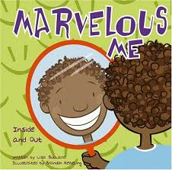
Friday 11th September 2019

Dear Parents and Carers,
As part of our “All About Me” topic, we are sending home a paper bag with the children this weekend. In class the children have decorated their bag and have written their name on it. With your help, at home, we would like the children to put a few small bits into the bag that are important to them or that tells us something about them. Examples include – a favourite book, a photo of their pet or something they made at home – to name but a few things. Please keep these items small and refrain from putting items in which the children cannot be parted from.
Over the course of the next few weeks we will encourage the children to show and tell the class about the contents of their bag. By half term, all bags will be returned.
We would also appreciate it if you could include a family photograph. This will be used for a whole class family collage display and will be returned at the end of the year.
Many thanks for your continued support,
The Reception Team.

Friday 11th September 2019

Dear Parents and Carers,
As part of our “All About Me” topic, we are sending home a paper bag with the children this weekend. In class the children have decorated their bag and have written their name on it. With your help, at home, we would like the children to put a few small bits into the bag that are important to them or that tells us something about them. Examples include – a favourite book, a photo of their pet or something they made at home – to name but a few things. Please keep these items small and refrain from putting items in which the children cannot be parted from.
Over the course of the next few weeks we will encourage the children to show and tell the class about the contents of their bag. By half term, all bags will be returned.
We would also appreciate it if you could include a family photograph. This will be used for a whole class family collage display and will be returned at the end of the year.
Many thanks for your continued support,
The Reception Team.

