

Welcome to Reception
We are really excited to welcome you to our Reception Bubble in September! In our Reception bubble you will taught and cared for by Miss Samuel and Mrs Rimmer.
You will start school on Monday 7th September, at the time allocated to you before the summer, in your information pack. Please wear your winter uniform to school. PE will be on Thursdays and Fridays so please come to school in your PE kit on those days (including blue jogging bottoms and blue jumpers/hoodies when it’s cold). Black or white trainers suitable for sport NOT fashion may be worn. You are not allowed to wear jewellery for PE (including earrings) so please make sure you have removed these before you come to school.
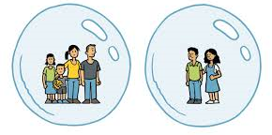
Our Reception Bubble will learn, play and eat together.
What to bring to our bubble
- Named water bottle
- Labelled Sunhat (if the weather is still nice)
- Labelled coat
- Named “own” soap / moisturiser for chapped hands (only if you wish)
- A piece of fruit or small pot/bag of fruit.
- A book bag

What not to bring
- Cuddly teddies
- Toys from home
- Pencil cases

You will come in to, and out of, our bubble through the Reception door.
On arrival at school
- Keep a 2m distance from other parents and children
- Go to peg, hang up coat
- Place water bottle and fruit snack in box, as shown
- Immediately wash hands

From Monday 14th September you will be coming in to school at slightly different times to some of your friends so here is our list – you need to find the first letter of your last name to work out what time you will come to school.
Start
8.45: A -F 8.50: G - M 8.55: N - Z All Finish 3.15 pm
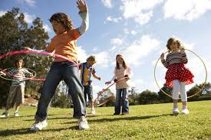
We will be having one morning playtime and lunch time. Mrs Westby will be looking after you at lunch time and you will eat lunch in the classroom from 12.00- 12.30pm and then go out to play from 12.30 until 1.00.

Our new school Christian value for Autumn term is Friendship, which will be a really lovely start to our new school year. Remember if you have any worries there are always lots of people you can talk to.
We will also be using email to contact your families, although we will only reply in office hours to make sure we all get a break from technology!
samuels@sps.sefton.school
Enjoy the rest of the holidays and we can’t wait to see you next week!
Love, The Reception team.


