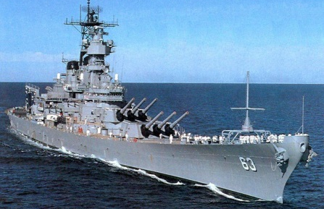
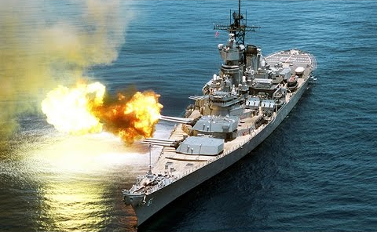
Book Battleships
Sink a ship by reading a book by one of these authors. Can you sink four in a row? Can you sink the entire fleet? Collect 10 Dojos for every row sunk!
A | Louis Sachar  Date: | Michael Morpurgo  Date: | Michael Rosen  Date: | Charles Dickens  Date:
B | Lewis Carroll  Date: | Philip Pullman  Date: | Anthony Browne  Date: | Nina Bawden  Date:
C | J K Rowling  Date: | Malorie Blackman  Date: | Robert Louis Stevenson  Date: | Clive King  Date:
D | CS Lewis  Date: | William Shakespeare  Date: | Anthony Horowitz  Date: | Frank Cottrell Boyce  Date:
E | 1 | 2 | 3 | 4

