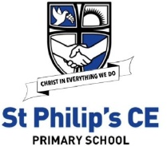
September 2020
Dear Parents / Carers in Year 5
Learning at home

Please find a list below of learning that your child can take part in should they need to access learning from home.
Children will need to log onto their class pages of the website for daily updates and also onto Purple Mash to complete tasks set. You will find a knowledge organiser for each subject for the Spring Term on the class website which will help you with key Information to support learning at home.
We suggest chunking up the time your child has in the day and focussing on short spells of learning in each subject. We have included a basic timetable from school to support you with this.
Each child can, if requested, have a blank exercise book to record their work in, but we suggest just using a nice notebook from home. High standards of presentation should be maintained. Any work in the book requires a date and a title. Once we return to school, the completed books and work should be sent back into school. We are unable to mark this work but we will most definitely reward effort. We suggest that a family member talks through tasks that the children have completed and we would welcome a written comment, smiley face or a note about any difficulties.
As always we would encourage project work and home research which our children (and Parents!) are so good at.
Thank you for your continued support. You can contact me via email during school hours with questions and queries related to learning.
Although this is a difficult time, keep on working hard and remember that we will all be back in school very soon. Enjoy your time at home, learning at your own pace. Be kind, be helpful and we’ll see you soon.
byrnel@sps.sefton.school
affordj@sps,sefton.school
Miss Byrne and Mrs Afford
English including phonics, reading, spelling, grammar and punctuation
See spelling overview on website – ‘ough’ spelling pattern and silent letters.

Brief overview of coverage until October half term: Cosmic! (Descriptive writing and persuasion.)

Class | Resource and what we use it for | Access information
Yr 5 | The piano | https://www.literacyshed.com/piano.html
Yr 5 | Spelling revision mats | https://st-philips-church-of-england-primary-school.secure-primarysite.net/spellings-9/
Yr 5 | BBC website | https://www.bbc.co.uk/programmes/b03g64pr
Yr 5 | Drama games | https://dramaresource.com/drama-games/
Yr 5 | Inverted commas revision | https://www.bbc.co.uk/bitesize/topics/zvwwxnb/articles/ztcp97h

Maths including times tables Place value,

Brief overview of coverage until Easter

Class | Resource and what we use it for | Access information
5 | 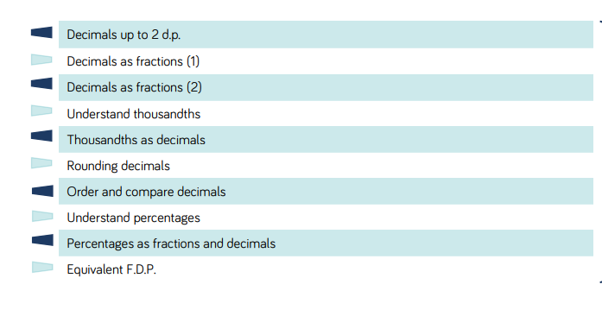 | White rose web site- click on Year 5 section for all activities  https://whiterosemaths.com/wp-content/uploads/2019/SoLs/Primary/Spring-Year-5-2018-19-Block-3-FINAL.pdf
5 | Decimals revision | https://www.bbc.co.uk/teach/class-clips-video/maths-ks2-decimal-dance-off-2-fractions-decimals-and-percentages/zk9ygwx
5 | TES website- will need to sign up (free) | https://www.tes.com/teaching-resource/year-5-summer-decimal-teaching-slides-white-rose-style-11866881
5 | Mental Arithmetic practice | http://www.mental-arithmetic.co.uk/Year-5-and-Year-6.htm
5 | Time tables practice | https://www.theschoolrun.com/times-tables
5 | Revision key facts | https://www.bbc.co.uk/teach/supermovers
5 | Revision of any key objectives | https://masterthecurriculum.co.uk/categories/?year=year-5

French
Brief overview of coverage until Easter Say what they would wear according to different weather.
End of unit assessment in listening, speaking, reading & writing
Class | Resource and what we use it for | Access information
5 | Useful website | https://www.duolingo.com/
5 | Useful resources | http://www.primaryresources.co.uk/mfl/mfl_french.htm
5 | BBC website | https://www.bbc.co.uk/bitesize/subjects/z39d7ty

Humanities (Geography ) Rivers – flooding, focus on one river , mapping a river, water falls

Brief overview of coverage until Easter
Class | Resource and what we use it for | Access information
5 | Possible writing tasks | https://www.purplemash.com/#tab/pm-home/topics/geography/rivers
5 | BBC Bitesize | https://www.bbc.co.uk/bitesize/topics/z849q6f/articles/z7w8pg8
5 | BBC Bite size- Water cycle | https://www.bbc.co.uk/bitesize/clips/zb39jxs

Science Properties and Changes of Materials

Brief overview of coverage until Easter

Class | Resource and what we use it for | Access information
5 | BBC Bitesize KS2 | https://www.bbc.co.uk/bitesize/topics/zryycdm
5 | Useful links | ttps://www.theschoolrun.com/homework-help/materials

Design Technology

Brief overview of coverage until Easter

Class | Resource and what we use it for | Access information
5 | Stem projects | https://www.stem.org.uk/resources/collection/2897/designing-key-stage-two

PE Gymnastics

Brief overview of coverage until Easter
Class | Resource and what we use it for | Access information
5 | Cosmic kids | https://www.youtube.com/user/CosmicKidsYoga
5 | Go Noodle | https://www.gonoodle.com/
5 | NHS change for life | https://www.nhs.uk/change4life
5 | WOW active cards | School website
5 | BBC Super movers | https://www.bbc.co.uk/teach/supermovers

RE Easter- Victory - Art work

Class | Resource and what we use it for | Access information
5 | RE story | https://www.youtube.com/watch?v=HL8R158Ujp4
5 | Easter writing ideas- Purple mash | https://www.purplemash.com/#tab/pm-home/topics/religiouseducation/re_christian/easter
5 | Easter | https://www.tes.com/teaching-resource/an-easter-enquiry-for-years-5-or-6-6431204
5 | Easter ideas | https://www.barnabasinschools.org.uk/

PSHE Relationships – You, me and RSE

Brief overview of coverage until Easter

Class | Resource and what we use it for | Access information
5 | BBC Bitesize KS1 – Covers all areas of PSHE | https://www.bbc.co.uk/bitesize/subjects/zmpfb9q
5 | One Decision | 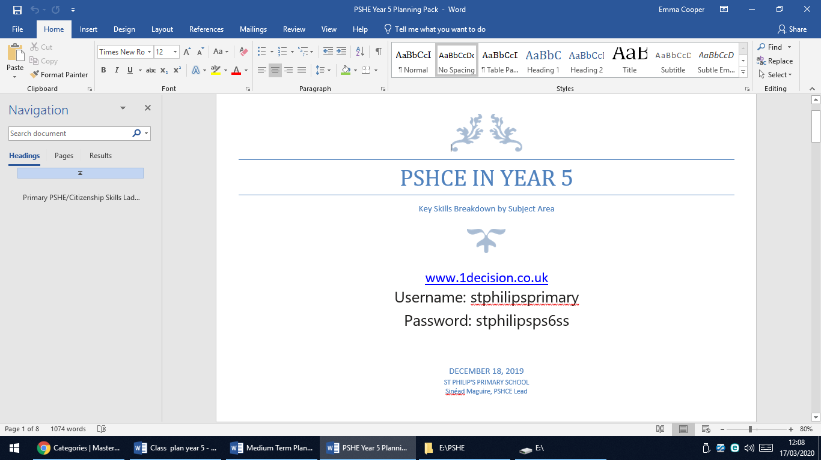

Music Eurovision song contest! Write own songs . Parts of an orchestra
Brief overview of coverage until Easter

Class | Resource and what we use it for | Access information
5 | BBC | http://www.bbc.co.uk/schools/websites/4_11/site/music.shtml
5 | Orchestra music | https://www.bbc.co.uk/teach/ten-pieces

This link is for children who have music lessons with Mr Dempsey -Music for Y5 & 6 - www.tacklemusic.co.uk/brasslessons Password - JDBrass
Useful websites for all subjects- free parent account will need to be created.
https://www.twinkl.co.uk/resource/year-5-school-closure-home-learning-resource-pack-t-e-2549914
https://classroomsecrets.co.uk/free-home-learning-packs/

