
November 2020
Dear Parents / Carers in Year 5
Learning at home
Monday | Tuesday | Wednesday | Thursday | Friday
Spellings | SPaG | SPaG | SPaG | Spelling Test
English | English | English | English | English
Break
Maths Key Skills | Maths Meeting | Maths Meeting | Maths Meeting | Maths Key Skills
Maths | Maths | Maths | Maths | Maths
Lunch
PE | Computing | History/  Geography | PE | French
PSHCE | RE | Science | Music | Art
Worship | Worship | Worship | Worship | Worship

Please find a list below of learning that your child can take part in should they need to access learning from home.
Children will need to log onto their class pages of the website for daily updates and also onto Purple Mash to complete tasks set. You will find a knowledge organiser for each subject for the Spring Term on the class website which will help you with key Information to support learning at home.
We suggest chunking up the time your child has in the day and focussing on short spells of learning in each subject. We have included a basic timetable from school to support you with this.
Each child can, if requested, have a blank exercise book to record their work in, but we suggest just using a nice notebook from home. High standards of presentation should be maintained. Any work in the book requires a date and a title. Once we return to school, the completed books and work should be sent back into school. We are unable to mark this work but we will most definitely reward effort. We suggest that a family member talks through tasks that the children have completed and we would welcome a written comment, smiley face or a note about any difficulties.
As always we would encourage project work and home research which our children (and Parents!) are so good at.
Thank you for your continued support. You can contact us via email during school hours with questions and queries related to learning.
Although this is a difficult time, keep on working hard and remember that we will all be back in school very soon. Enjoy your time at home, learning at your own pace. Be kind, be helpful and we’ll see you soon.
byrnel@sps.sefton.school
hankinsone@sps.sefton.school
Miss Byrne and Miss Hankinson

English including phonics, reading, spelling, grammar and punctuation
See spelling overview on website – -ible and -able suffixes, homophones and -cious and -tious.

Brief overview of coverage until Christmas: The Highwayman (classical poetry) and explanation text (Science link.)

Class | Resource and what we use it for | Access information
Y5 | Reading – Serial Mash | Purple Mash
Y5 | Writing Tasks | School website, Purple Mash ‘to dos’
Y5 | Highwayman poem | https://www.poetryfoundation.org/poems/43187/the-highwayman
Y5 | Spellings | School website
Y5 | Spelling revision mats | https://st-philips-church-of-england-primary-school.secure-primarysite.net/spellings-9/
Y5 | SPaG activities | https://www.bbc.co.uk/bitesize/topics/zhrrd2p
Y5 | BBC website | https://www.bbc.co.uk/programmes/b03g64pr
Y5 | Drama games | https://dramaresource.com/drama-games/
Y5 | BBC Super Movers – PE twist on various subjects | https://www.bbc.co.uk/teach/supermovers
Y5 | Inverted commas revision | https://www.bbc.co.uk/bitesize/topics/zvwwxnb/articles/ztcp97h
Y5 | Grammar games | https://www.topmarks.co.uk/english-games/7-11-years/spelling-and-grammar

Maths including times tables

Brief overview of coverage until Christmas: Statistics, multiplication and division, perimeter and area.

Class | Resource and what we use it for | Access information
Y5 | White Rose scheme | White Rose requires a subscription, but all resources will be posted on school website.  Teaching videos will be linked (Vimeo)
Y5 | Maths games (variety of topics for revision) | Links on school website, including https://www.topmarks.co.uk/maths-games/7-11-years/times-tables
Y5 | Decimals revision | https://www.bbc.co.uk/teach/class-clips-video/maths-ks2-decimal-dance-off-2-fractions-decimals-and-percentages/zk9ygwx
Y5 | TES website- will need to sign up (free) | https://www.tes.com/teaching-resource/year-5-summer-decimal-teaching-slides-white-rose-style-11866881
Y5 | Mental Arithmetic practice | http://www.mental-arithmetic.co.uk/Year-5-and-Year-6.htm
Y5 | Time tables practice | https://www.theschoolrun.com/times-tables  Purple Mash, Times Tables Rockstars
Y5 | Maths games | https://www.topmarks.co.uk/maths-games/7-11-years/times-tables
Y5 | Revision key facts | https://www.bbc.co.uk/teach/supermovers
Y5 | Revision of any key objectives | https://masterthecurriculum.co.uk/categories/?year=year-5
Y5 | BBC Super Movers – PE twist on various subjects | https://www.bbc.co.uk/teach/supermovers
Y5 | Worksheets on key concepts, free to register | https://masterthecurriculum.co.uk/

Humanities (Geography)

Brief overview of coverage until Christmas: Mapping unit.

Class | Resource and what we use it for | Access information
Y5 | Weekly tasks | School website
Y5 | Sustrans Southport Neighbourhood Project | https://www.sustrans.org.uk/
Y5 | Southport information | https://www.visitsouthport.com/
Y5 | Maps info | https://www.bbc.co.uk/teach/class-clips-video/geography-ks1--ks2-maps/zdwhpg8  https://www.bbc.co.uk/bitesize/topics/zvsfr82/articles/zdk46v4
Y5 | Creating maps | https://www.geography.org.uk/download/ga_conf12barlowpgce.pdf
Y5 | Ordnance Survey website | https://www.ordnancesurvey.co.uk/education/teacher-resources
Y5 | Royal Geographical Society | https://www.rgs.org/schools/teaching-resources/map-skills/
Y5 | Google Earth | https://www.google.com/earth/
Y5 | Landscape Map Skills | http://www.bbc.co.uk/scotland/education/sysm/landscapes/
Y5 | Grid References game | http://resources.hwb.wales.gov.uk/VTC/grid_refs/eng/Activity/default.htm
Y5 | Compass Bearings | http://resources.hwb.wales.gov.uk/VTC/compass_bearings/eng/Onlineactivity/default.htm

Science

Brief overview of coverage until Christmas: Forces

Class | Resource and what we use it for | Access information
Y5 | Weekly tasks | School website
Y5 | BBC Bitesize KS2 | https://www.bbc.co.uk/bitesize/topics/znmmn39
Y5 | Useful links | https://www.theschoolrun.com/what-is-a-force
Y5 | Forces intro | https://www.youtube.com/watch?v=7bCHNeNLel8
Y5 | Common forces, forces and magnets | https://www.youtube.com/watch?v=kmtDbF3b4ns
Y5 | What is a force? | https://vimeo.com/168139447
Y5 | Resistive forces | https://www.schoolsofkingedwardvi.co.uk/ks2-science-year-5-5a-forces-resistive-forces/
Y5 | Water and air resistance | https://www.bbc.co.uk/bitesize/topics/zsxxsbk/articles/zxw6gdm
Y5 | Levers and pulleys | https://nustem.uk/wp/wp-content/uploads/2015/01/On-the-Move-5Mar15.pdf

PE

Brief overview of coverage until Christmas: football and dance
Class | Resource and what we use it for | Access information
Y5 | Tasks and ideas | School website
Y5 | Football fun activity pack | https://plprimarystars.com/resources/football-fun-activity-pack#m-resource-2272-link
Y5 | The Body Coach | https://www.youtube.com/playlist?list=PLyCLoPd4VxBuxu3sLztrvWFehzv-LnR2c
Y5 | Cosmic kids | https://www.youtube.com/user/CosmicKidsYoga
Y5 | Go Noodle | https://www.gonoodle.com/
Y5 | NHS change for life | https://www.nhs.uk/change4life
Y5 | WOW active cards | School website
Y5 | BBC Super movers | https://www.bbc.co.uk/teach/supermovers

RE

Brief overview of coverage until Christmas: Jesus the Teacher, Christmas Around the World

Class | Resource and what we use it for | Access information
Y5 | Weekly tasks | School website
Y5 | Jesus as Teacher information | https://likeateam.com/9-characteristics-of-jesus-as-a-teacher/ https://www.openbible.info/topics/jesus_the_teacher
Y5 | Parables of Jesus | https://www.youtube.com/watch?v=4r9M2Xlyw7M Pearl of Great Price  https://www.youtube.com/watch?v=IZEO_Ls2ERs Parable of the Sower  https://www.youtube.com/watch?v=Jb0YTNdYxIs&feature=youtu.be Build upon rock  https://www.youtube.com/watch?v=_Ry2MaMyvGo&feature=youtu.be Parable of the Lost Sheep  https://www.youtube.com/watch?v=fO4qSAhI1sI&feature=youtu.be Parable of the Good Samaritan
Y5 | Christmas celebrations and customs around the world | https://www.whychristmas.com/cultures/  https://www.kids-world-travel-guide.com/christmas-around-the-world.html  https://www.bbc.co.uk/newsround/15790210  https://www.educationworld.com/a_lesson/Christmas-Around-the-World-Lessons-and-Activities.shtml
Y5 | Online Bible | www.biblesociety.co.uk
Y5 | Applied Christianity activities | https://www.barnabasinschools.org.uk/
Y5 | Useful resources and videos | https://www.reonline.org.uk/

PSHE Relationships

Brief overview of coverage until Christmas: Getting on and Falling Out, 1Decision: Keeping Safe

Class | Resource and what we use it for | Access information
Y5 | Weekly task | School website
Y5 | BBC Bitesize KS1 – Covers all areas of PSHE | https://www.bbc.co.uk/bitesize/subjects/zmpfb9q
Y5 | One Decision | 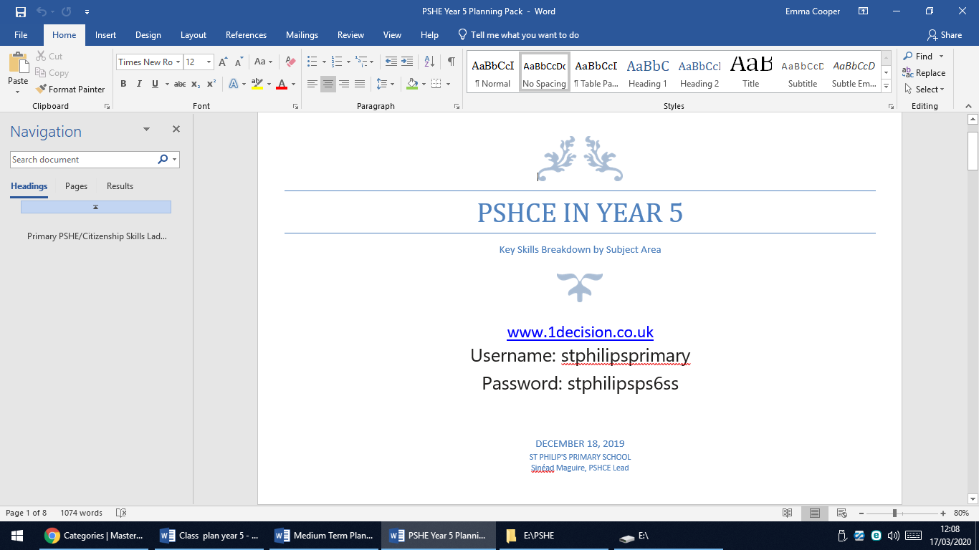
Y5 | Emotions tool box | https://www.childline.org.uk/toolbox/
Y5 | Growth mindset videos | https://www.youtube.com/watch?v=oQG4vFGd6eU  https://www.youtube.com/watch?v=vPuRBiBCxyk
Y5 | The Boy, The Mole, The Fox and The Horse (video of book) | https://www.youtube.com/watch?v=WMVc8afLFG0

Music
Brief overview of coverage until Christmas: Stars Hide you Fires (percussion, rhythm)

Class | Resource and what we use it for | Access information
Y5 | Weekly tasks | School website
Y5 | BBC | http://www.bbc.co.uk/schools/websites/4_11/site/music.shtml
Y5 | Orchestra music | https://www.bbc.co.uk/teach/ten-pieces
Design Technology

Brief overview of coverage until Christmas

Class | Resource and what we use it for | Access information
Y5 | Stem projects | https://www.stem.org.uk/resources/collection/2897/designing-key-stage-two
Y5 | Enjoy making something creative | https://www.youtube.com/user/mistermaker

French

Brief overview of coverage until Christmas: The Weather

Class | Resource and what we use it for | Access information
Y5 | Weekly tasks | On school website
Y5 | Useful website | https://www.duolingo.com/
Y5 | Useful resources | http://www.primaryresources.co.uk/mfl/mfl_french.htm
Y5 | BBC website | https://www.bbc.co.uk/bitesize/subjects/z39d7ty

Computing

Brief overview of coverage until Christmas: Spreadsheets

Class | Resource and what we use it for | Access information
Y5 | Weekly tasks | On school website
Y5 | Useful help for spreadsheets | https://www.primaryresources.co.uk/ict/ict2.htm  https://www.schoolsofkingedwardvi.co.uk/ks2-computing-information-technology-5-spreadsheets-charts/n
Y5 | Weekly tasks and activities | Purple Mash
Y5 | Bitesize Revision of Computing Skills | https://www.bbc.co.uk/bitesize/subjects/zvnrq6f

This link is for children who have music lessons with Mr Dempsey -Music for Y5 & 6 - www.tacklemusic.co.uk/brasslessons Password – JDBrass

Useful websites for all subjects- free parent account may need to be created.
https://www.thenational.academy/
https://classroomsecrets.co.uk/free-home-learning-packs/
https://www.twinkl.co.uk/resource/year-5-school-closure-home-learning-resource-pack-t-e-2549914
https://www.hamilton-trust.org.uk/blog/learning-home-packs/
http://www.primaryhomeworkhelp.co.uk/
https://thirdspacelearning.com/blog/home-learning-resources/

