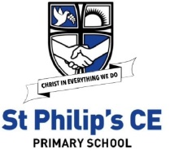
January 2021
Dear Parents / Carers in Year 5
Learning at home
Monday | Tuesday | Wednesday | Thursday | Friday
Spellings | SPaG | SPaG | SPaG | Spelling Test
English | English | English | English | English
Break
Maths Key Skills | Maths Meeting | Maths Meeting | Maths Meeting | Maths Key Skills
Maths | Maths | Maths | Maths | Maths
Lunch
Science | History | Computing | PSHE | RE
Music | French | Gymnastics/PE | PE | Art
Worship | Worship | Worship | Worship | Worship

Please find a list below of learning that your child can take part in should they need to access learning from home.
Children will need to log onto their class pages of the website for daily updates and also onto Purple Mash to complete tasks set. You will find a knowledge organiser for each subject for the Spring Term on the class website which will help you with key information to support learning at home.
We suggest chunking up the time your child has in the day and focussing on short spells of learning in each subject. We have included a basic timetable from school to support you with this.
Each child can, if requested, have a blank exercise book to record their work in, but we suggest just using a nice notebook from home. High standards of presentation should be maintained. Any work in the book requires a date and a title. Once we return to school, the completed books and work should be sent back into school. We are unable to mark this work but we will most definitely reward effort. We suggest that a family member talks through tasks that the children have completed and we would welcome a written comment, smiley face or a note about any difficulties.
As always, we would encourage project work and home research which our children (and parents!) are so good at.
Thank you for your continued support. You can contact us via email during school hours with questions and queries related to learning.
Although this is a difficult time, keep on working hard and remember that we will all be back in school very soon. Enjoy your time at home, learning at your own pace. Be kind, be helpful and we’ll see you soon.
byrnel@sps.sefton.school
hankinsone@sps.sefton.school
Miss Byrne and Miss Hankinson

English including phonics, reading, spelling, grammar and punctuation
See spelling overview on website – plurals (adding -s, -es or -ies. Words ending -cial or -tial. Words ending -tious.)

Brief overview of coverage until half term: Stories from Other Cultures (narrative) and Report Writing (African theme)

Class | Resource and what we use it for | Access information
Y5 | Reading – Serial Mash | Purple Mash
Y5 | Daily Tasks | School website, Purple Mash ‘to dos’
Y5 | Stories from Other Cultures - texts | https://vimeo.com/23455377  https://www.youtube.com/watch?v=gh3erSSTQnk
Y5 | Report writing | https://www.bbc.co.uk/bitesize/clips/zdmw2hv  https://www.theschoolrun.com/what-is-a-non-chronological-report
Y5 | Spellings | School website  https://classroom.thenational.academy/subjects-by-year/year-5/subjects/english-spelling
Y5 | Spelling revision mats | https://st-philips-church-of-england-primary-school.secure-primarysite.net/spellings-9/
Y5 | SPaG activities | https://www.bbc.co.uk/bitesize/topics/zhrrd2p
Y5 | Relative Clauses | https://www.bbc.co.uk/bitesize/topics/zwwp8mn/articles/zsrt4qt  https://www.youtube.com/watch?v=HbVIIuhgg9Y
Y5 | BBC website | https://www.bbc.co.uk/programmes/b03g64pr
Y5 | Drama games | https://dramaresource.com/drama-games/
Y5 | BBC Super Movers – PE twist on various subjects | https://www.bbc.co.uk/teach/supermovers
Y5 | Inverted commas revision | https://www.bbc.co.uk/bitesize/topics/zvwwxnb/articles/ztcp97h
Y5 | Grammar games | https://www.topmarks.co.uk/english-games/7-11-years/spelling-and-grammar

Maths including times tables

Brief overview of coverage until half term: perimeter and area, multiplication and division, fractions

Class | Resource and what we use it for | Access information
Y5 | White Rose scheme | White Rose requires a subscription, but all resources will be posted on school website.  Teaching videos will be linked (Vimeo)
Y5 | Maths games (variety of topics for revision) | Links on school website, including https://www.topmarks.co.uk/maths-games/7-11-years/times-tables
Y5 | Decimals revision | https://www.bbc.co.uk/teach/class-clips-video/maths-ks2-decimal-dance-off-2-fractions-decimals-and-percentages/zk9ygwx
Y5 | TES website- will need to sign up (free) | https://www.tes.com/teaching-resource/year-5-summer-decimal-teaching-slides-white-rose-style-11866881
Y5 | Mental Arithmetic practice | http://www.mental-arithmetic.co.uk/Year-5-and-Year-6.htm
Y5 | Time tables practice | https://www.theschoolrun.com/times-tables  Purple Mash, Times Tables Rockstars
Y5 | Maths games | https://www.topmarks.co.uk/maths-games/7-11-years/times-tables
Y5 | Revision key facts | https://www.bbc.co.uk/teach/supermovers
Y5 | Revision of any key objectives | https://masterthecurriculum.co.uk/categories/?year=year-5
Y5 | BBC Super Movers – PE twist on various subjects | https://www.bbc.co.uk/teach/supermovers
Y5 | Worksheets on key concepts, free to register | https://masterthecurriculum.co.uk/

Humanities (History)

Brief overview of coverage until half term: Ancient Civilisations (Egypt)

Class | Resource and what we use it for | Access information
Y5 | Weekly tasks | School website
Y5 | Ancient Civilisations research | https://www.bbc.co.uk/teach/class-clips-video/history-ks2-lost-lands/zfp6gwx  Purple Mash
Y5 | Ancient Egypt clip bank | https://www.bbc.co.uk/bitesize/topics/zg87xnb
Y5 | Ancient Egypt timeline and facts | https://www.theschoolrun.com/homework-help/egyptian-life-and-culture
Y5 | Museum links | https://www.britishmuseum.org/learn/schools/ages-7-11/ancient-egypt
Y5 | Daily life in Ancient Egypt | https://www.bbc.co.uk/bitesize/topics/zg87xnb/articles/zr4s8xs
Y5 | Mummification | https://www.bbc.co.uk/teach/class-clips-video/history-social-studies-ks2-mummification-in-ancient-egypt/zdcrkmn
Y5 | Egyptian gods and goddesses | https://www.bbc.co.uk/bitesize/topics/zg87xnb/articles/z4m8pg8  https://www.natgeokids.com/uk/discover/history/egypt/ancient-egypt-gods/  https://www.historyforkids.net/egyptian-gods.html
Y5 | Ancient Egypt videos | https://www.youtube.com/watch?v=T7WhIybg_Qo Horrible Histories  https://www.youtube.com/watch?v=aEK6PT7K8OM importance of Nile  https://www.youtube.com/watch?v=k5aqxTlGSIs Tutankhamun’s tomb  https://www.youtube.com/watch?v=hMV2JZzGsa8 social pyramid  https://www.youtube.com/watch?v=FcCFZ3SXQns daily life in Ancient Egypt

Science

Brief overview of coverage until half term: properties and changes of materials (water cycle)

Class | Resource and what we use it for | Access information
Y5 | Weekly tasks | School website https://www.stphilipssouthport.com/year-groups/
Y5 | Grouping materials | https://www.schoolsofkingedwardvi.co.uk/ks2-science-year-5-3c-materials-grouping-materials/
Y5 | Properties of materials | https://www.stem.org.uk/resources/community/collection/12742/year-5-properties-materials
Y5 | Types of materials | https://www.bbc.co.uk/bitesize/topics/zryycdm
Y5 | Separating materials – how can we separate materials? | https://www.youtube.com/watch?v=JJeY-muIqhw
Y5 | Changing materials – states | https://www.bbc.co.uk/bitesize/topics/zcvv4wx
Y5 | What is the water cycle? | https://www.bbc.co.uk/bitesize/topics/zkgg87h/articles/z3wpp39
Y5 | Water cycle experiment | https://www.youtube.com/watch?v=K5dd7LOjOcs
PE

Brief overview of coverage until half term: gymnastics and swimming
Class | Resource and what we use it for | Access information
Y5 | Tasks and ideas | School website
Y5 | Gymnastics at home | https://www.youtube.com/watch?v=7ohkDqnhQcQ
Y5 | The Body Coach | https://www.youtube.com/playlist?list=PLyCLoPd4VxBuxu3sLztrvWFehzv-LnR2c
Y5 | Cosmic kids | https://www.youtube.com/user/CosmicKidsYoga
Y5 | Go Noodle | https://www.gonoodle.com/
Y5 | NHS change for life | https://www.nhs.uk/change4life
Y5 | WOW active cards | School website
Y5 | BBC Super movers | https://www.bbc.co.uk/teach/supermovers

RE

Brief overview of coverage until half term: Women in the Old Testament

Class | Resource and what we use it for | Access information
Y5 | Weekly tasks | School website
Y5 | Important women in the Bible | https://www.compassionuk.org/blogs/5-strong-women-bible/
Y5 | The story of Ruth and Naomi | https://www.youtube.com/watch?v=YIeRJmLDeQ0
Y5 | The story of Deborah | https://www.youtube.com/watch?v=GakKDNn2_YE
Y5 | The story of Esther | https://www.youtube.com/watch?v=OVzlTfwKS5s
Y5 | Applied Christianity activities | https://www.barnabasinschools.org.uk/
Y5 | Useful resources and videos | https://www.reonline.org.uk/

PSHE Relationships

Brief overview of coverage until half term: Going for Gold, 1Decision: Looking Out for Others

Class | Resource and what we use it for | Access information
Y5 | Weekly task | School website
Y5 | BBC Bitesize KS1 – Covers all areas of PSHE | https://www.bbc.co.uk/bitesize/subjects/zmpfb9q
Y5 | One Decision | 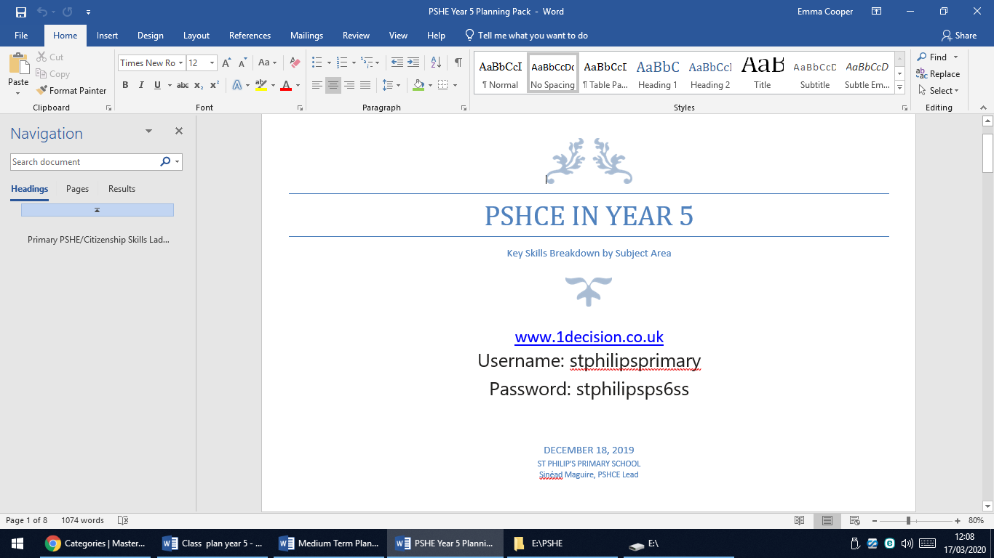
Y5 | Emotions tool box | https://www.childline.org.uk/toolbox/
Y5 | Growth mindset videos | https://www.youtube.com/watch?v=oQG4vFGd6eU  https://www.youtube.com/watch?v=vPuRBiBCxyk
Y5 | BBC | https://www.bbc.co.uk/bitesize/subjects/zqtnvcw

Music
Brief overview of coverage until half term: African drumming (percussion, rhythm)

Class | Resource and what we use it for | Access information
Y5 | Weekly tasks | School website
Y5 | BBC | http://www.bbc.co.uk/schools/websites/4_11/site/music.shtml
Y5 | Orchestra music | https://www.bbc.co.uk/teach/ten-pieces
Design Technology

Brief overview of coverage until half term

Class | Resource and what we use it for | Access information
Y5 | Stem projects | https://www.stem.org.uk/resources/collection/2897/designing-key-stage-two
Y5 | Enjoy making something creative | https://www.youtube.com/user/mistermaker

French

Brief overview of coverage until half term: the planets

Class | Resource and what we use it for | Access information
Y5 | Weekly tasks | On school website
Y5 | Useful website | https://www.duolingo.com/
Y5 | Useful resources | http://www.primaryresources.co.uk/mfl/mfl_french.htm
Y5 | BBC website | https://www.bbc.co.uk/bitesize/subjects/z39d7ty

Computing

Brief overview of coverage until half term:

Class | Resource and what we use it for | Access information
Y5 | Weekly tasks | On school website
Y5 | Weekly tasks and activities | Purple Mash
Y5 | Coding | https://www.bbc.co.uk/teach/class-clips-video/computing-ks1--ks2-programming-a-computer-game/zn8d7nb
Y5 | ‘Cracking the code’ | https://www.bbc.co.uk/teach/class-clips-video/computing-ks1--ks2-cracking-the-code/z7ntgwx
Y5 | Code club – coding activities | https://projects.raspberrypi.org/en/codeclub
Y5 | Bitesize Revision of Computing Skills | https://www.bbc.co.uk/bitesize/subjects/zvnrq6f

This link is for children who have music lessons with Mr Dempsey -Music for Y5 & 6 - www.tacklemusic.co.uk/brasslessons Password – JDBrass

Useful websites for all subjects- free parent account may need to be created.
https://www.thenational.academy/
https://classroomsecrets.co.uk/free-home-learning-packs/
https://www.twinkl.co.uk/resource/year-5-school-closure-home-learning-resource-pack-t-e-2549914
https://www.hamilton-trust.org.uk/blog/learning-home-packs/
http://www.primaryhomeworkhelp.co.uk/
https://thirdspacelearning.com/blog/home-learning-resources/

