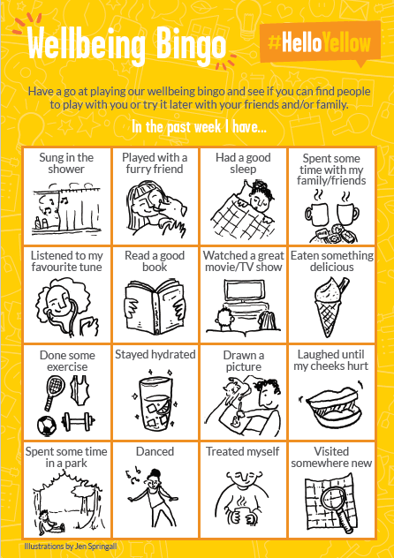
Links and Resources
There will be a version of this document on the Year 5 homework page for you to access the links more easily! Take care, love from Miss Byrne
For Children
https://www.childline.org.uk/toolbox/games/
https://www.childline.org.uk/toolbox/games/boost-your-mood/
https://www.bbc.co.uk/newsround/54456177
https://www.mindful.org/mindfulness-for-kids/
https://www.headspace.com/meditation/kids
For Grown Ups
https://www.nhs.uk/oneyou/every-mind-matters/childrens-mental-health/#custom-2column-share-shelf
https://youngminds.org.uk/starting-a-conversation-with-your-child/
https://maudsleycharity.org/familiesunderpressure/
https://www.nhs.uk/live-well/
https://www.mind.org.uk/information-support/for-children-and-young-people/

