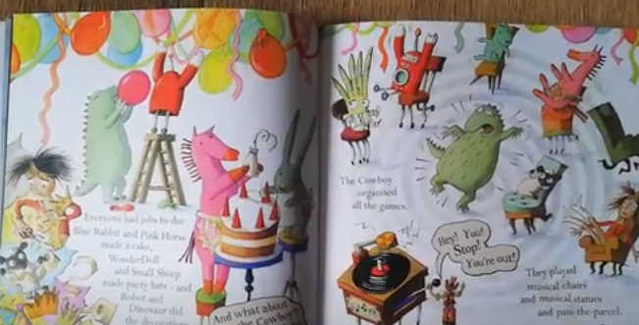
Monday 9th November LO To be able to join two sentences using the conjunction ‘and’.
Hoctopize’s Party

.

