Tuesday 10th November
LO To be able to use the conjunction ‘and’ to make sentences longer.
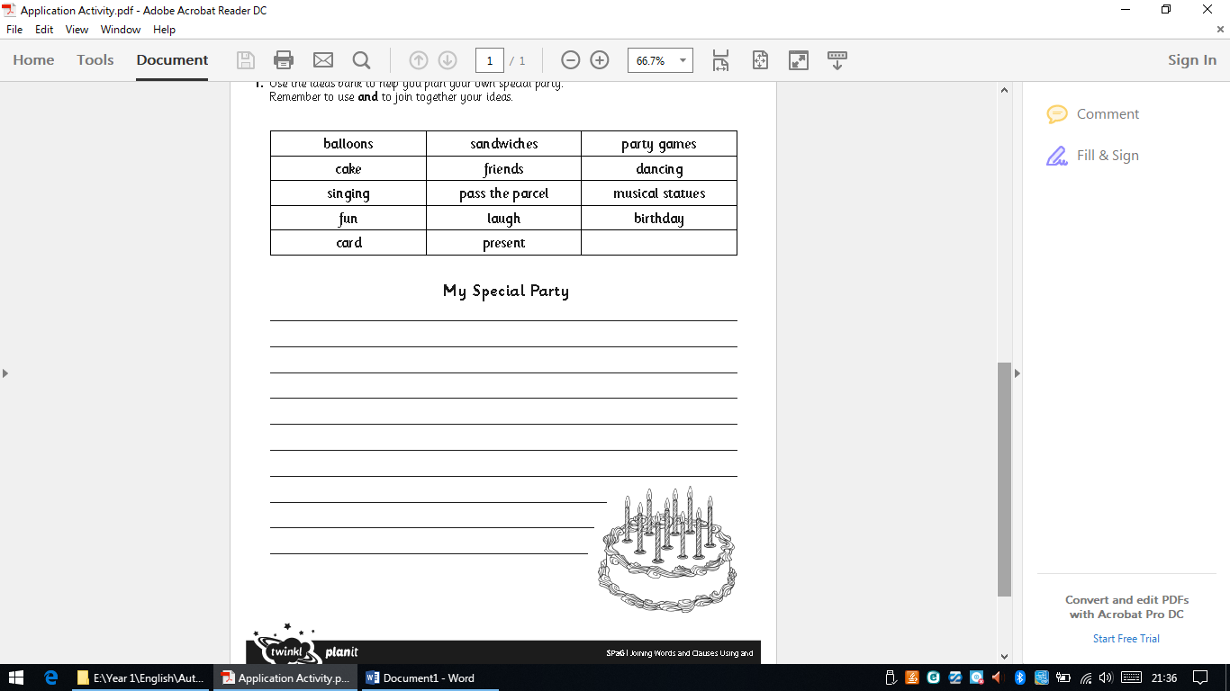
I will be looking for:
Capital letters and full stops
Neat writing
Finger spaces
Sentences which make sense.
The word ‘and’ to make sentences longer

