Wednesday 3rd December
LO. To rewrite the story from the point of view of the boy.
Feeding of the five thousand Matthew 14:(13-21)
Useful words
loaves and fishes Jesus disciples crowd hungry
bread

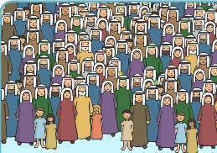


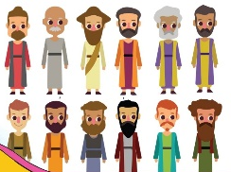

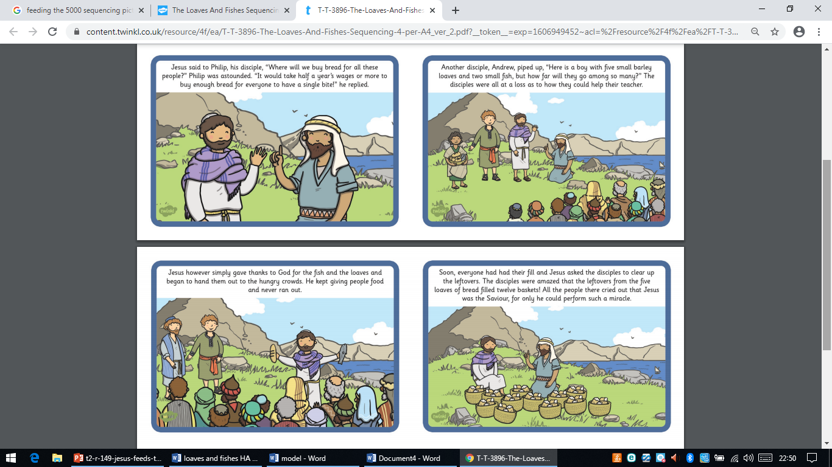
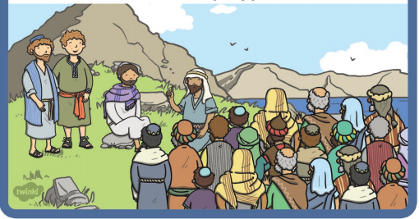
The crowd were hungry.
Wednesday 3rd December
LO. To

