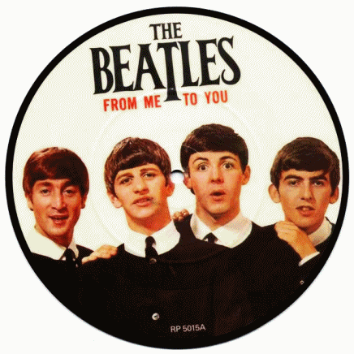 Year 1 The Beatles History
We are now learning all about our new topic, The Beatles, who came from Liverpool. This half term, please try to find out some interesting facts about The Beatles or the city of Liverpool. If you have any Beatles items or photos at home that you would like to share with me and the rest of the class, that would be great! Just email them to me or share pictures on our class blog.
___________________________________________________________________________________________________________________________________________________________________________________________________________________________________________________________________________________________________________________________________________________________________________________________________________________________________________________________________________________________________________________________________________________________________________________________________________________________________________________________________________________________________________________________________________



