Monday 14th September
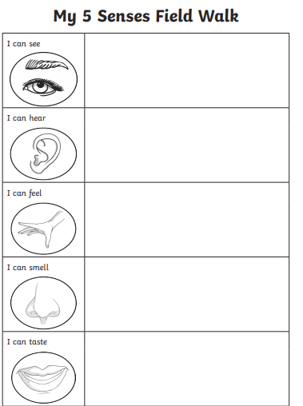
LO To say which part of the body is to do with each sense

