Monday 14th September
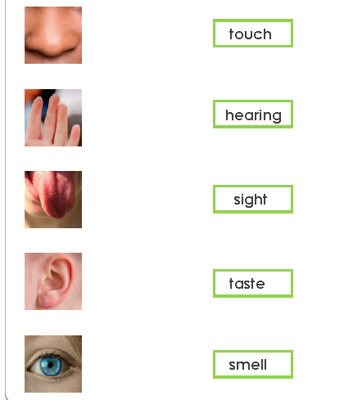
LO I can match up parts of the body with its sense.

