15.9.20 LO To read numbers to 10 and order them, starting with the smallest.

Write the numbers in the boxes
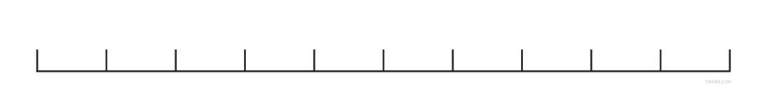
Cut out the numbers and order them on the number line
three
one
nine
seven
four
zero
ten
six
five

eight

two

0

