16.4.21 Can you fill in all the empty coxes in the table below and put the numbers on the number line?
Lo To be able to move between digits, pictorial representations, number names and number structures
Number in digits
31
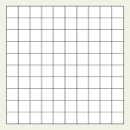  colour in 100 square |  | 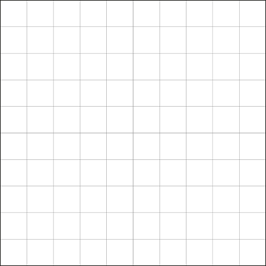
Number in words | nineteen
How many tens and ones?  _______ tens  and  _________ ones | __________ tens  and  _________ ones | __________ tens  and  ________ ones | 4 tens  and  3 ones

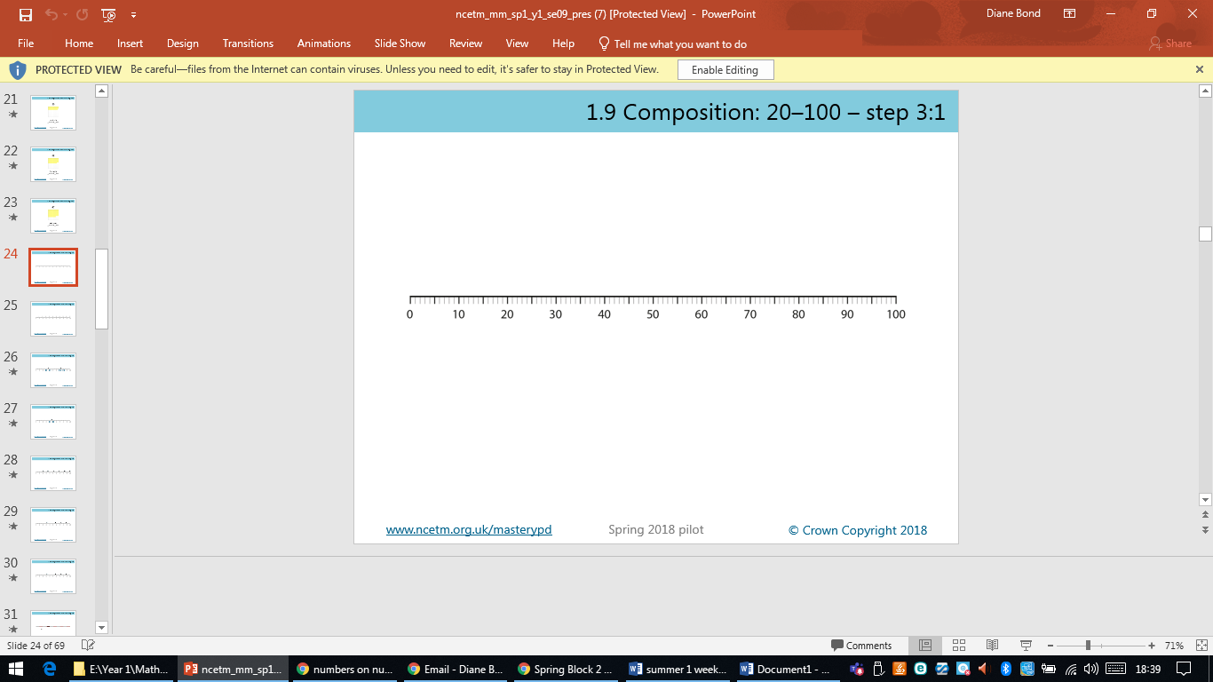
31

