Year 1 news Thank you so much for helping your children to make their stick men and ladies, they are all so different and amazing. They have already written a description of them and next week they will write a story about them. We had a lovely time making Easter gardens this week, I hope you have had chance to have a look at them outside the classroom. We are still waiting for our beans to sprout, hopefully we will see a little shoot before we break up for Easter. Please ask your children to teach you how to play ‘Bat it back’ to practise their number bonds. Once they are confident making number bonds to 10, then you can try making 20.

Homework 19.3.21
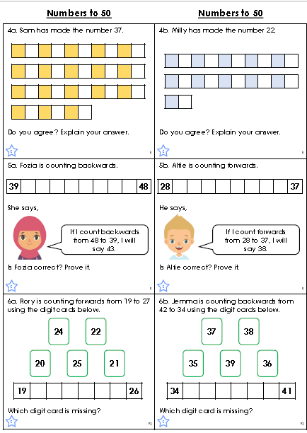
We are working on numbers to 50 in maths and have been learning about how place value.

