New vocabulary
catastrophic | ____________________________________  ____________________________________
____________________________________
____________________________________
____________________________________
____________________________________
____________________________________
____________________________________
____________________________________
____________________________________
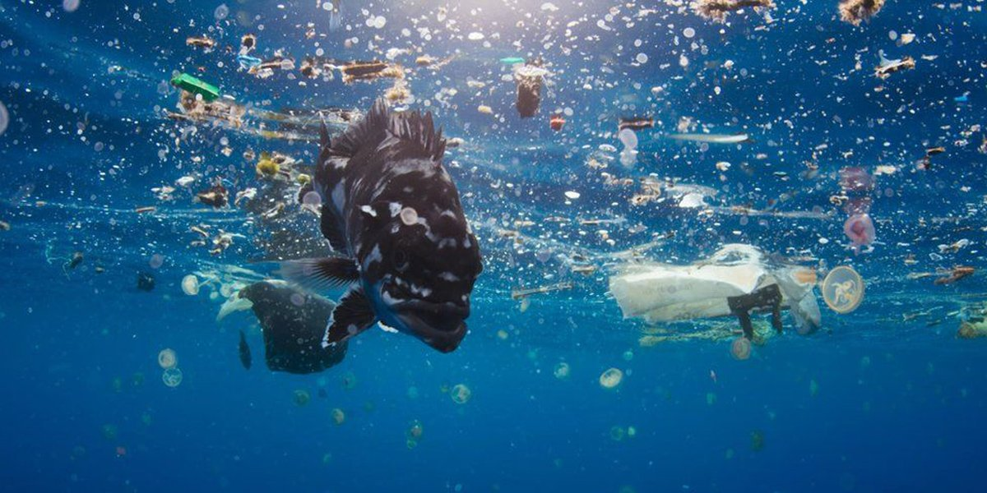
Dear David Lewis,

On behalf of my primary school, I am writing to you today regarding the recent topic that is evidently affecting not just our country but indeed our planet: plastic pollution. As I am sure you are already aware of the catastrophic damage being had and the implications this is having on our environment, not to mention the threat plastic is posing to our marine life in our vast oceans. In Year 6, we have been discussing and researching the damage that has been caused globally and would like to express our concerns on this matter and hear how your company: ‘Tesco’ are making a change for the better.

Plastic pollution is a serious problem and one that if left unattended to and ignored, will leave future generations at a loss. Each year, approximately 100 million marine animals are killed, due to plastic debris in our oceans. Of which, each microscopic piece of plastic that has ever entered our oceans is still there. At St Philip’s CE Primary School, we believe that this needs to change. If more were to be done in the retail business about single use plastic, this would have a positive impact to our planet.

The recycling of plastic has proven almost impossible as most plastic materials are not biodegradable thus will not break down and decompose like other materials. In the media, we have learnt that Tesco is one of the supermarkets that are actively trying to start to make changed in your industry. The use of carrier bags have significantly reduced due to there now being a cost of at least 5pence per bag. Yet, despite extending the 5p charge on single-use plastic bags, major retailers in England still sold 2.1 billion in the last financial year. As you are very much aware, Tesco holds a powerful position being one of the largest UK supermarkets. Therefore, by making changes to single plastic items, your company could make major positive changes in contributing to the reduction of plastic waste.

Subordinating conjunction sentences:
____________________________________________________________________________________________________________________________________________________________________________________________________________________________

Facts and figures:
____________________________________________________________________________________________________________________________________________________________________________________________________________________________________________________________________________________________________________________________________________________________________________________

Effective sentence starters (adverbials):
____________________________________________________________________________________________________________________________________________________________________________________________________________________________

New vocabulary
____________________________________
____________________________________
____________________________________
____________________________________
____________________________________
____________________________________
____________________________________
____________________________________
____________________________________
____________________________________
Formal phrases:
______________________________________________________________________________________________________________________________________________________________________________________________________________________________________________________________________________________________________________________________________________________________________________________________________________________________________________________________________________________________________________________________________________________________________
I am aware of some of the proposals Tesco are wanting to make, such as by 2025, Tesco wants all its packaging to be recyclable or compostable and its total packaging weight to be halved compared to 2007.It has removed all polystyrene from its fish packaging, and claims that more than 78% of its packaging is recyclable, though this depends on the type of material accepted by local authorities. Whilst the proposals are looking to make some changes in the plastic industry, I cannot help but ponder on the sheer volume of single use plastic that is consumed in each household per week just because of packaging.

Despite concerning statistics highlighting the devasting impact single use plastic waste has on our oceans, not all companies are acting to make a difference. The more that single packaging is discouraged in supermarkets, the more we are helping save our planet. If businesses continue to ignore the facts, if companies choose to not act, if you choose to do nothing, then it will be too late. We hope, therefore, that you will be able to enlighten us on what other ideas you have on helping reduce the amount of single use plastic in your company. I understand that other supermarkets such as Waitrose are encouraging customers to shop using their own reusable packaging. Is this something that you would also consider? I trust this matter will receive your prompt attention.

I look forward to hearing from you,
Yours sincerely,

Complex sentences:
_________________________________________________________________________________________________________________________________________________________________________________________________________________________________________________________________________________________________________________________________________________________________________________________________
Facts and figures:
_______________________________________________________________________________________________________________________________________________________________________________________________________________________________________________________________________________________________________________________________________________________________________________________________________________________________________________________________________________________________________________

