

Welcome to Greenbank
Greetings and a warm welcome to Year 6 pupils, parents and carers. Here at Greenbank we make every effort to ensure our new pupils have a smooth transition into secondary school. We have already received your Greenbank admission Forms and probably spoken with your Year 6 to support your move. Normally prior to joining us, we arrange a number of information, taster, and transition events for Year 6 pupils and their parents or carers, such as a parents' information evening, Transition Days, and Summer School.
Due to the current global situation, and lockdown we have had to adapt our normal transition procedures to ensure that we stay in touch and are able to offer advice, information and support. The new procedures are likely to include video conference meetings at the end of June with us via our online platform, Google Meet, in order for us to gradually get to know each other and our form groups before September. We still hope to run our successful Summer School in a safe format.
Over the next few weeks we will be sending information on life here at Greenbank and how to prepare for Year 7. Sometimes it’s helpful to put a name to a face, as the expression goes. We are:




Mr Raikes Mrs Collins-Murphy Mrs Howe
Your New Headteacher Your Head of Year 7 SENDCO Teacher/Coordinator
A message from Mr Raikes – Headteacher
I would like to warmly welcome you to our school which we are so proud of. I look forward to learning all your names. You are joining a school that truly wants to inspire you with a wide range of experiences and opportunities both in and out of class We will care for you through our supportive staff, who will help you along every step of your Greenbank journey helping you to achieve great things in your school life! I look forward to us helping you settle in, in order for you to be happy and not worried about anything.
A message from Mrs Collins –Murphy – Head of Year 7
I hope you are all safe and well. We are living through history right now and we will be able to look back on this time when you start in Year 7. You are part of the Greenbank High School family now and it would be great if you could share your experiences with us now or when you start in September.
In the coming weeks key information will sent to you and posted on our website and YouTube channel. Check out our fantastic video that pupils took part in last year. You may recognise some faces! https://www.youtube.com/watch?v=FQWGxCpGQpA&t=5s.
We will update you and your family with transition details and hopefully provide some opportunities for you to connect with your new form teachers, fellow pupils and ANGELS. Angels stands for “A New Girls Easy Listening Service” and is made up of lovely Year 10 pupils who are keen to help and advise you here at Greenbank. Please do not worry; we will do our very best to make this as smooth as possible for you in these difficult circumstances.
I look forward to meeting you all.
Mrs Collins-Murphy
A Message from Mrs Howe- SENDCO
Welcome to Greenbank! I know a lot of you may be a little nervous about starting in high school, but I would like to assure you, that as a new comer myself (I joined in April last year) Greenbank is truly a lovely place to attend. When you arrive in September we have a fabulous Study Support centre and mentoring team to support those of you who are a bit worried or have any barriers to your learning, and I am sure that you will love the other members of my team -such as Jess the reading dog! I look forward to meeting you all soon.

One of the highlights in preparing for transition to secondary school is the new school uniform.
Our Uniform
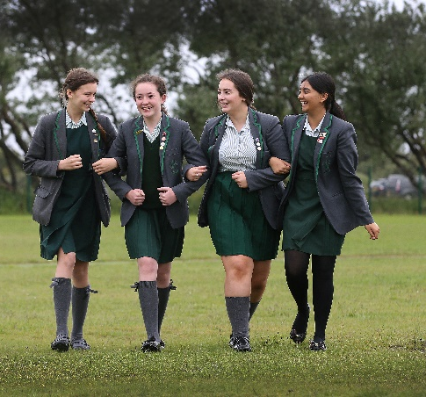
- Compulsory grey blazer with green trim and green school badge.
- Dark green ‘A’ line or pleated skirt or pinafore dress of a modest length.
- Dark green tailored trousers.
- Green and white striped blouse with a flat collar.
- Plain grey or green knee-length socks. If tights are worn they must be
grey or black.
- Shoes must be all black. Any logos must be covered or removed.
- Optional Dark green v-necked pullover/cardigan with school logo.
- A plain dark coat or jacket.
- Hair bands, bobbles (which are needed to tie hair back in practical
subjects) or head scarves should be black or green.

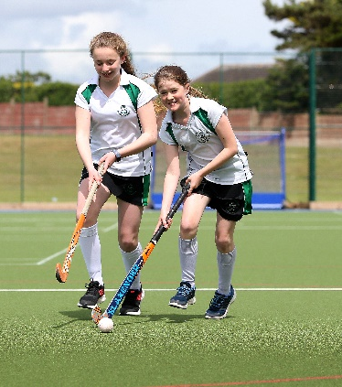
For Physical Education
- White sports shirt with green trim, Greenbank badge and initials.
- Black skorts or shorts with green and white trim (for all activities).
- Black with green and white trim hooded sweatshirt with Greenbank badge.
- Black track pants (optional to be used during the winter).
- Trainers.
- ¾ length white sports socks.
- We recommend shin pads and a gum shield for hockey.
- No jewellery should be worn on PE days in the interest of health and safety.

All articles of clothing must be named with sewn-in labels or permanent marker.
Kit should be kept in a large drawstring bag, also named. Other open type bags are inadequate and may lead to kit being lost. Only this bag should be taken to PE lessons.
“Whittakers” and “Zips and Snips” are the main suppliers based in Southport. Whittakers have contacted us with the following information. (Zips and Snips can only be contacted at the present time through Facebook)

How to Purchase School Uniform
Option 1
Place your order online – www.whittakersschoolwear.co.uk (vouchers cannot be used online)
Ordering your uniform online means that you don’t have to leave your home. On their website you will need to click on the SHOP tab, then click on Southport, and locate Greenbank school uniform.
Please try to order as soon as possible, to avoid not having your uniform in time for the start of term in September.
Option 2
Make an appointment with Whittakers to shop in store, at 35/39 London Street, PR9 0UY.
To ensure the safety of staff and customers through social distancing, they will be operating a strict appointment only service in the shop. This means that we will not be allowing customers’ entry to the shop unless a prior appointment has been made.
You will be able to make your appointment from 22/06/2020 by downloading the Booksy app (available through app stores on both Apple and Android phones) and searching Whittakers Schoolwear.co.uk Southport or you can visit www.whittakersschoolwear.co.uk and click on the BOOK APPT tab.
If you would like to visit their shop, please make your appointment as soon as you can after 22/06/2020. They will have extended opening hours over the summer including evenings and Sundays. If you find that all appointments have been taken, and the shop is fully booked, you will have no option but to order your uniform online. Anyone who turns up to the shop without an appointment will be turned away.

We hope this information has been helpful. Further updates and information to follow.

