

GREENBANK HIGH SCHOOL



“A booklet to help with your journey to Greenbank”

First name (what do you like to be known as):

Second name:

Primary School:



Introduction


Hi! I’m Mrs Collins-Murphy and I will be your Head of Year when you join us at Greenbank. I’m really looking forward to meeting you and welcoming you to Greenbank. One of the most exciting things about joining a new school is getting to know everybody: your form tutor, teachers, and most importantly your new classmates! There are so many new things for you to discover but I understand that making the journey from Primary to High School may seem a little scary or daunting but rest assured we are here to help.

For any journey, you need to do lots of preparation – planning how you’ll get there, what to wear and what to take.

Preparation helps you:

To think about where you’re going and how it will be different

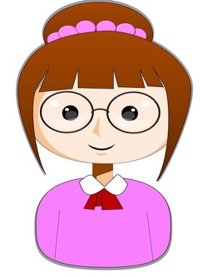



To feel confident and good about yourself

To say goodbye to who and what you’ll be leaving behind



It is a journey, not just for you but for your family and it’ll mean changes for them too.
Year 6
Year 7

This booklet has some fun activities to do before you start at Greenbank. You’ll get some more ‘getting to know you’ activities once you start school; so do not worry if you don’t know
anyone just yet.

Talk to your family about the activities.

Bring your “This is Me” Booklet with you in September so that you can show your new Form Tutor– this will help them to get to know you a bit faster.

Your Profile

You are going to complete your Profile together with your family or at school. This activity will let you talk about and think about what you would like your new form teacher to know about you! It also helps you to think positively about yourself which is important when you are about to start a new school.

Think about the positive aspects of your personality… the good things about being you! And what you like doing to show your new form teacher.

(It isn’t easy to be positive about yourself… so maybe ask a family member to help you).

My Profile Sheet

ASK YOURSELF THESE QUESTIONS:

    - What do you enjoy?
    - What are you good at?
    - What do people like about you?
    - What makes you smile?
    - What is good about you as a friend?
    - What are your favourite lessons?
    - What do you like doing in your spare time?

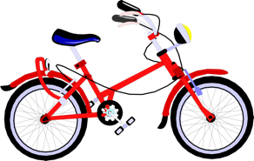









Jot down your responses to the above questions
Write here

ACTIVITY
Pick your 4 favourite things that you or someone else has said about you and write them in the four speech bubbles on the next page.

MY 4 FAVOURITE THINGS ABOUT MYSELF



You and Your Home



At home I like to…

Write here…

WHO LIVES WITH ME?
(Pets included!)

Write here…



Getting Organised- Things you need to succeed!

You will have lots of questions. The following activities will help you prepare with planning, how you’ll get to Greenbank, what to take with you, what to wear and what you need to buy. Talk to your family and get organised.

Travelling to Greenbank

Greenbank may be further away from where you live, and it is important to plan and practice your new journey to school ready for September.

What is the best way to get there?
Read the bubbles. Which questions do need to think and talk about? Maybe colour them in.

How am I getting to school?
Who will drive me?
What is the quickest way?

Where is the bus stop?
What time do I have to leave?

How long will it take?

Will I go with a friend?

Is there a school bus?
Where can I leave my bike?

Where can I leave my helmet?
Is my jacket bright enough?
Will I get a lift home?

Should I get a bike lock?

- At Greenbank there are buses that drop you off and pick you up on school grounds (your family will be sent the information before September and it is on our website).

- Greenbank is a five minute walk away from Hillside Station and there is also a Bus Stop for public buses.

- If you would like to cycle to school we have bike sheds. You will need a good lock and you can keep your helmet in your locker.

- The School day starts at 8:35am and ends at 3:10pm. You should aim to be in school by 8:30am.

Write down your plan for how you might get to Greenbank High School (how long would it take, what time should you leave home at?)

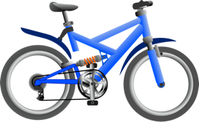
My Journey Plan



Write here




Once you have decided the safest and quickest way to and from Greenbank High School, set a date and practice the journey.

Date: ………………………….. Time: …………………………

Who is going? ………………………………………………………………

How long did it take you? …………………………………………

What time do I need to leave the house? ………………………………………….
(Remember that there might be more traffic in September so leave some extra time)

BE SAFE - Your safety is very important and will be one of the main things your family will worry about. Agree together what your rules will be to make sure you stay safe, happy and healthy.

Think about:

When you’ll get home
Crossing roads

Who’ll be at home?
Cars seeing you easily

If you’re late
Going to the park

Buying sweets or fizzy drinks
Using the internet

Going to other people’s houses after school

Texting or ringing your family so they know you’re OK



Getting Organised: Uniform

Schools have different uniforms for lots of different reasons. It shows other people which school you go to, and it saves having to decide what to wear to school each day! Look together at the information from Greenbank High School – you can find a list of our uniform through the following link:
https://greenbankhigh.co.uk/school-uniform/

The main difference between Greenbank High School and your primary school will be trainers – you are not allowed to wear trainers (even black ones) to school.

My PE Kit Shopping List
My Uniform Shopping List


Coping with Change

Your routine will change when you start Greenbank. Talk with family and friends and try and work out what your new routine will look like.

Some top routine tips … follow and you can’t go wrong!

- Make sure all your belongings have your name on.
- Pack your bag the night before – always use your timetable to help you
- Always have your homework diary in your bag
- Set the alarm clock leaving enough time to have breakfast, and make sure you are clean, and smart wearing the correct uniform
- Leave the house with plenty of time for your journey to school

Write down any worries you have and who might help you..

Worried about friends? A solution could be to meet up or talk with someone else who is starting at Greenbank. TOP TIP Joining clubs is a great way of
making new friends. We have clubs for sports, performing arts, music, cookery and many others. We will tell you all about them when you join us in September.

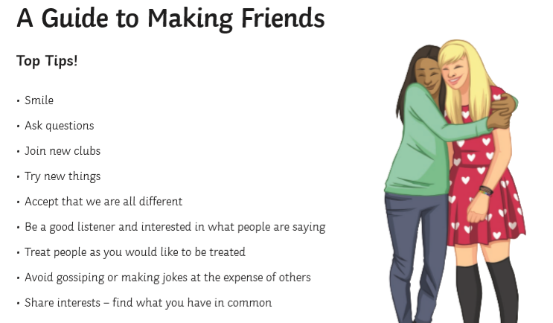
Fresh Start

Starting at Greenbank High School is going to give you something very valuable: A completely fresh start!

Think of the person you are right now.
Answer these questions:

Are you the best version of yourself?
Do you challenge yourself?
Do you have a can do attitude or do you tend to give up?
Could you have done things differently?
Do you struggle with friendships?

When you start at Greenbank, you will have a completely new slate, a new beginning, a fresh start!


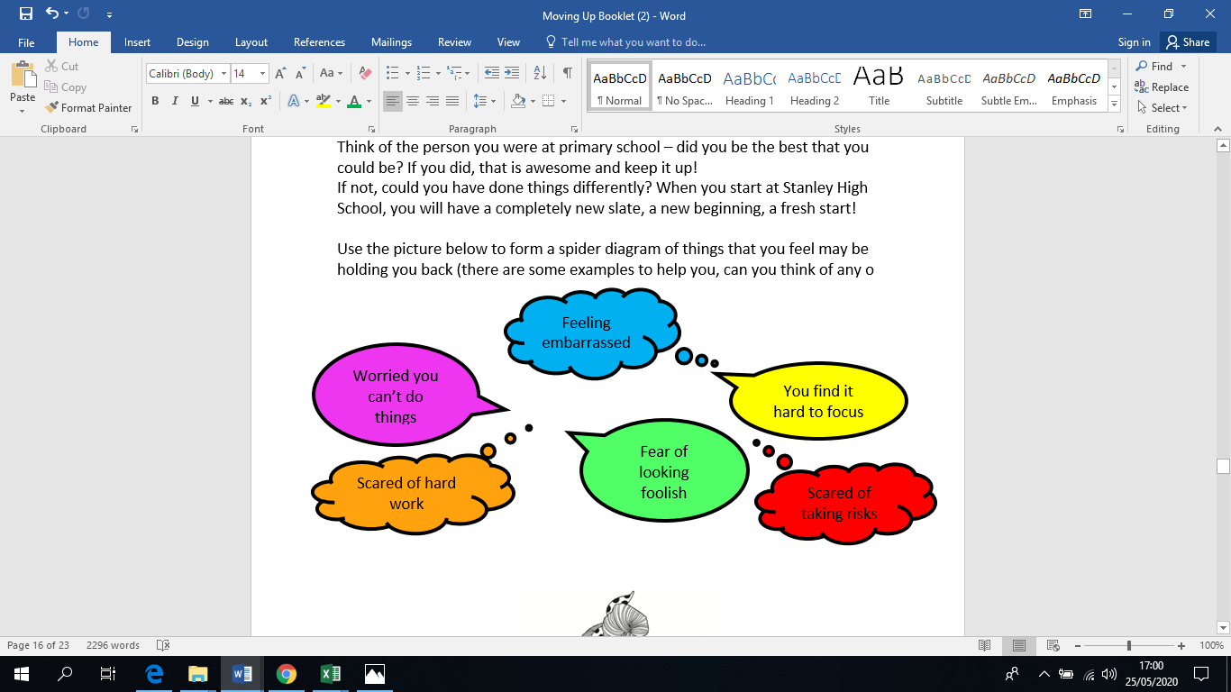

DO YOU SOMETIMES RELATE TO THE FEARS ABOVE? HAVE THEY HELD YOU BACK IN THE PAST?

Write here any worries or concerns…..

Write down what you can learn from your primary school experience ahead of joining Greenbank High School.

How did you handle things when they went wrong?



How did you react when you got stuck?

Think about a time when you showed an amazing attitude. Write about it here:


This Photo by Unknown Author is licensed under CC BY-SA

Write about the kind of person you want to be at Greenbank.

WHICH MINDSET DO YOU HAVE?

We can sometimes become negative when we don’t get things right straight away. At Greenbank we want to help you achieve your full potential.

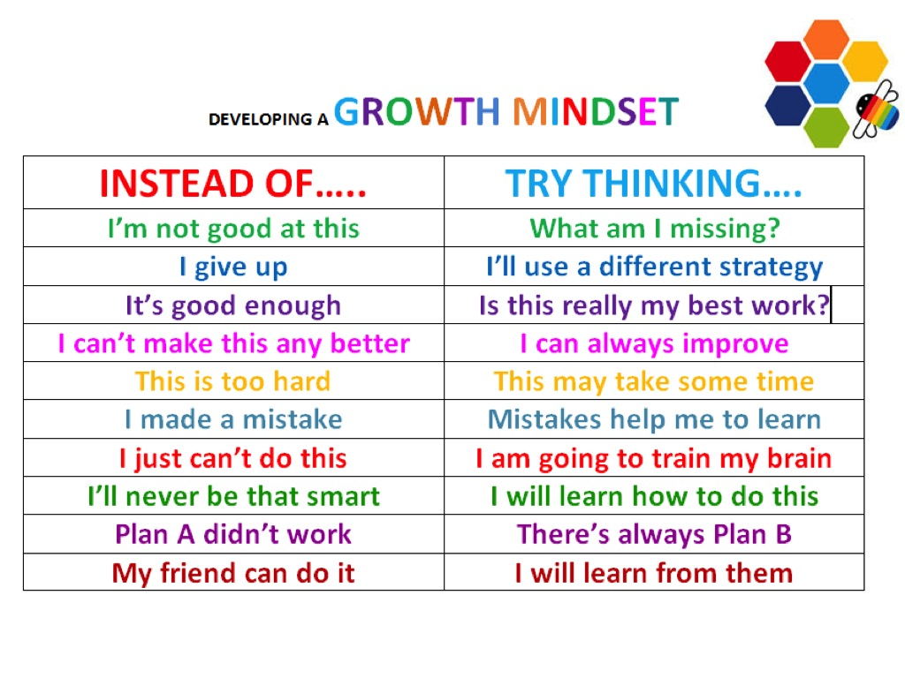
Some Year 6 students say that they are worried about the following:

Not making friends
The work being too hard

Not knowing where to go

You may be worrying about homework. Well don’t. You will be expected to work hard but there is always someone to help you – we even have a Homework Club with the Learning Mentors on hand to help you if you get stuck. Homework is not given to Year 7 pupils for the first couple of weeks but then it is given in Maths, Science and English just to ease you into a proper homework timetable.

THESE WORRIES ARE NORMAL!

All Teachers will encourage you to think positively and extra help is available from your Form Tutors, Mentors and Study Support Team
Write down 3 things that you think you can’t do or worry about
Now try to rewrite your 3 answers that you write above using a GROWTH MINDSET. For example, ‘I can’t do Maths’ turns into ‘I am going to practise the things in Maths that I can’t do yet’.


Write here

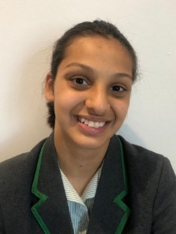
ANGELS- A NEW GIRLS EASY LISTENING SERVICE
We understand that sometimes it’s good to talk to someone other than teachers! This is why we have “Angels”. Angels are specially trained Year 10 pupils who are keen to help and advise you in any way they can, remember they were Year 7 once! Here are pictures of some of your Year 10 Angels who can’t wait to meet you.
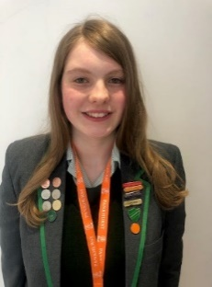
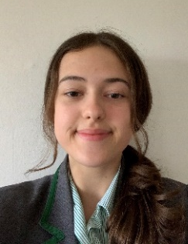
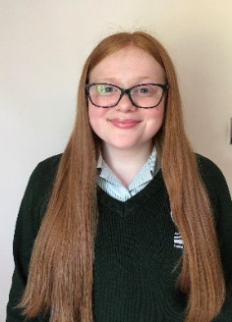
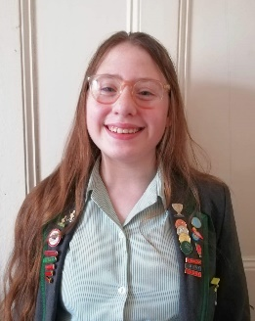


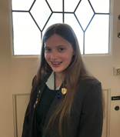
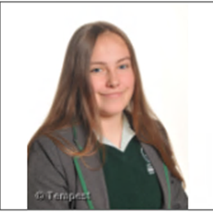

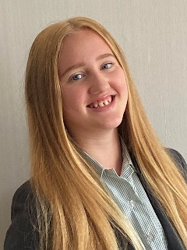
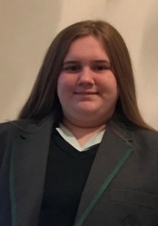
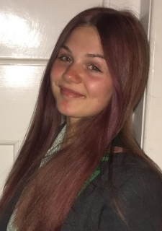


We can’t wait to meet you!
In the meantime checkout our welcome video that has been especially made for you and links to our Greenbank YouTube channel.

https://www.youtube.com/watch?v=UGxaNJNW9Tk

https://www.youtube.com/watch?v=FQWGxCpGQpA&t=135s

https://www.youtube.com/watch?v=W3_VUHYLQ2k

