

Welcome to Year 6!
We are really excited to welcome you to our Year 6 Bubble in September! In our year group will be Mrs Cooper, Mrs Warham, Mrs Lund and Mrs Day.
You will continue to have your own work pack filled with all the stationery you’ll need and will sit at a desk of two, spaced out and facing the front of the classroom. Please wear your winter uniform to school, PE will be on Monday and Friday so please come to school in your PE kit that day (including blue jogging bottoms and blue jumpers/hoodies when it’s cold). Just a reminder that earrings should be taken out for P.E and the latest guidance from Sefton is that they can not be covered with tape now. White or black trainers suitable for sport NOT fashion should be worn.
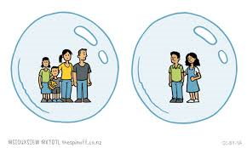
Our Year 6 Bubble will learn, play and eat together.
What to bring to our bubble
- Named water bottle
- Labelled Sunhat (if the weather is still nice)
- Labelled coat
- Named “own” soap / moisturiser for chapped hands (if you wish)
- A small pot/bag of fruit for break time, which has been labelled
- Your inhaler if you use one
- School bag

What not to bring
- Cuddly teddies
- Toys from home
- Pencil cases

You will come in to, and out of, our bubble through the Junior playground door.
On arrival at school
- Keep a 2m distance from other parents and children
- Maintain 2m distance from the teacher on the door
- Go to peg, hang up coat
- Place water bottle and fruit snack on your desk
- Immediately wash hands

You will be coming in to school at slightly different times to some of your friends so here is our list – you need to find the first letter of your last name to work out what time you will come to school.

Start (Juniors)
8.45: A -F 8.50: G - M 8.55: N - Z All Finish 3.20 pm
If you will be walking to, and from school, on your own, please ask your parents to send a short note (or email) in to let me know.
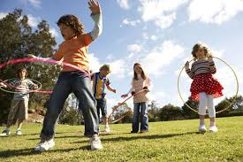
We will be having one morning playtime and lunch time. Mrs Hudson will be looking after you at lunch time and you will go out to play first from 12.00- 12.30 pm, and then eat lunch in the classroom.

Our new school Christian value for Autumn term is Friendship, which will be a really lovely start to our new school year. Remember if you have any worries there are always lots of people you can talk to – we are so blessed in Year 6 to have two Teaching Assistants to help and listen to you!
Homework will be given out on a Friday, due in the following Wednesday. Spellings will be tested on a Friday and we will continue with our Key skills tests in Maths and daily class reading or IDL sessions.
Don’t forget the ‘Covid summer catch up’ page on the Year 5 class web page- there are some fun activities on there to get your brains active and ready for school! Also please don’t forget your logins for the computers, Purple Mash, and Times Table Rockstar as we will be using these lots more in September! Now we are all experts at using our class web pages we will be putting some powerpoints from our lessons on there to help you in class and to revise at home (and show your parents if you want to!) We will also be using email to contact your families a lot more, although we will only reply in office hours to make sure we all get a break from technology!
Have a lovely summer and we can’t wait to see you next week!
Love, The Year 6 team
Mrs Cooper, Mrs Warham, Mrs Lund and Mrs Day



