History home learning project challenge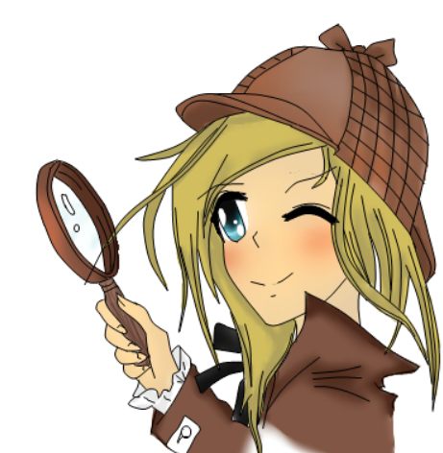
Choose a time or event in history that you are interested in (it can be one you have already studied and know something about or a completely new one) and think about a question you could investigate the answer to and that will take you several weeks and lead to a lovely project for us to read, watch or listen to.
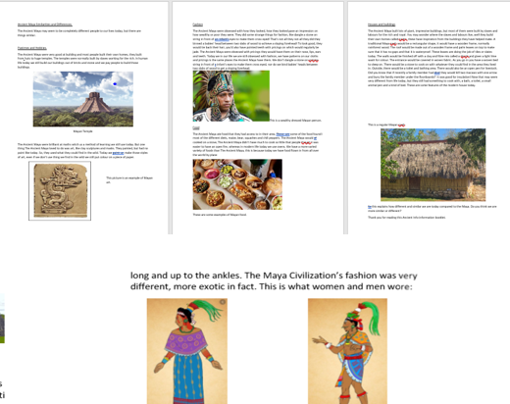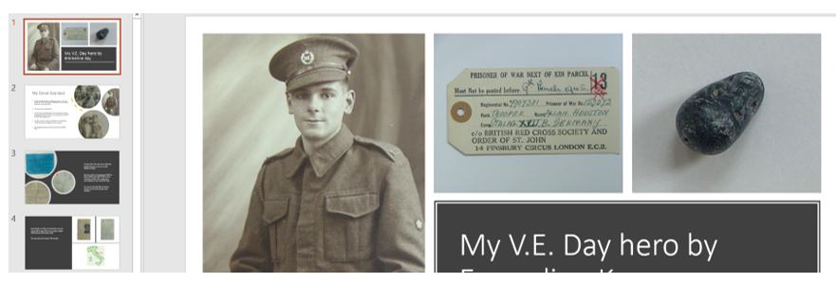
The best questions to really get you thinking start with – Should, Were and Was. These allow you to show both sides of a topic and then to weigh them up.
Here are some examples from eras you’ve already studied:
- Were Stone Age people really savage?
- Was the Roman invasion good for Britain?
- Were the Ancient Egyptians more civilised than the Romans?
- Should we really remember the Vikings as vicious?
- Were lives in Victorian times better than lives in Tudor times?
For these topics you’d need to look at a range of life experiences e.g. for rich and poor, men and women, free people and slaves, different religious groups maybe. You could have a big speech bubble approach for each type of person (point of view).
OR you might prefer to research some famous people from the list below and compare how important they have been?
OR to celebrate other cultures/civilisations like Ancient China, or the Islamic Golden Age – asking What was so great about…?
OR to share some interesting family history or local history…
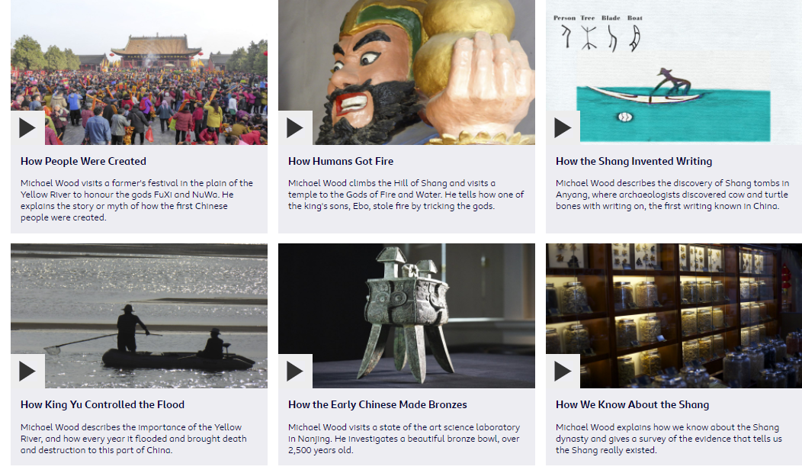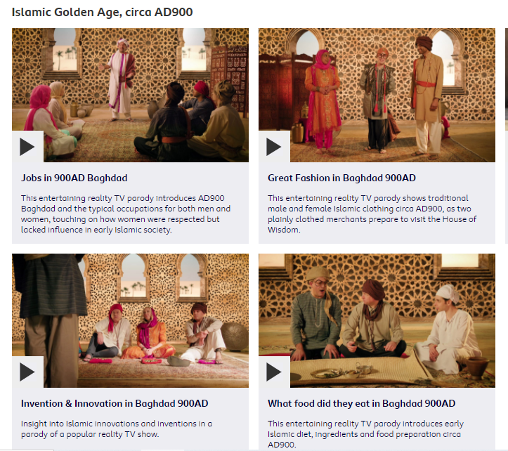
How to present it - It can be done as a traditional paper project…handwritten and illustrated, or word processed with illustrations from the internet…a mixture of the two OR as a PowerPoint of video.
Time scales
Week 1 – question and plan of action
The first week is simply to come up with a question and an idea of what different sections you will have and how you will research for this.

Week 2 - introduction
To present the introduction – this is where you set the scene and explain facts which answer the basic questions like…Where? When? Who? Why people have this idea about a group of people or time in history. It is good to include a map.

Week 3 and 4 - research
This is your research phase…finding out and taking notes to use later. Remember to look for different viewpoints e.g. lives of men and women, rich and poor etc. Keep a list of what websites, books or even people you have used

Week 5 and 6 – presenting your findings
This is for putting together your chapters/sections…remember this can be done as a video or PowerPoint with voice over.

Week 7 - conclusion
This is a very important section. You are putting together your conclusion where you weigh up what you have found out. There should be at least two sides to weigh up e.g.

What might seem savage about the Stone Age and what might not
What might seem vicious about the Vikings and what seems more peaceful
What was good and what was bad for Britain when the Romans invaded
What seems more civilised about the Egyptians and what does not…. what seems more civilised about the Romans and what does not
What is good and what is bad about Tudor times…what is good and what is bad about Victorian times
BUT where there are different experiences it might be more complicated e.g. better for some people…worse for others…you MUST explain this
Week 8 - Bibliography
Making sure it is all finished off with a Bibliography…this is a list of the websites, books, videos etc that you have used.
Resources
https://www.bbc.co.uk/bitesize/subjects/zcw76sg
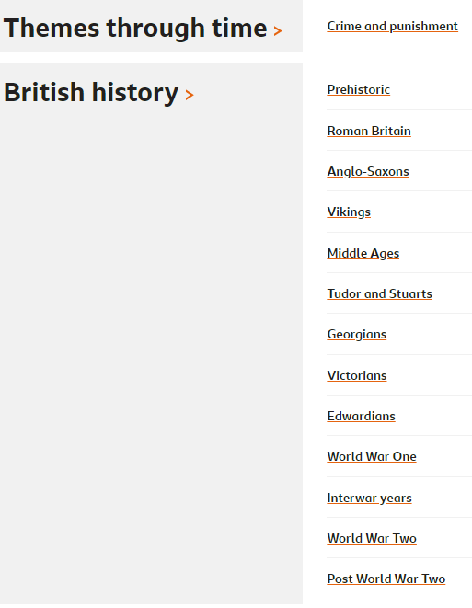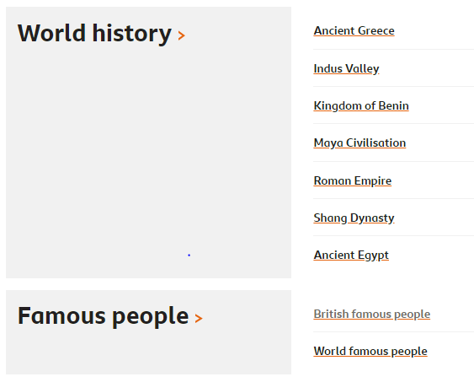
https://www.bbc.co.uk/teach/class-clips-video/history-ks2-lost-lands/zfp6gwx
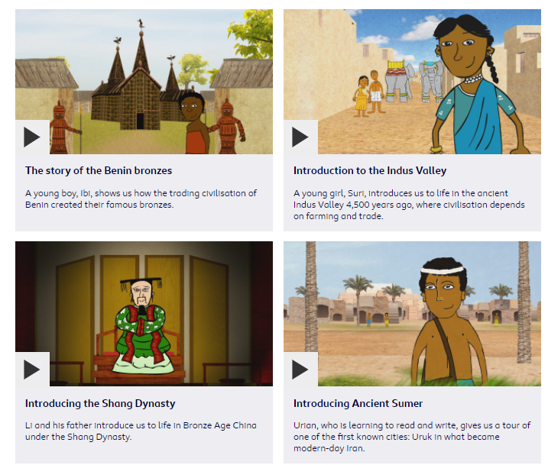
https://www.bbc.co.uk/teach/class-clips-video/ks2-ks3-history-of-early-civilisations/zvm647h
https://www.bbc.co.uk/teach/class-clips-video/history-ks2-the-story-of-china/z6mq382

https://www.bbc.co.uk/teach/class-clips-video/history-ks1--ks2-true-stories/z72wpg8
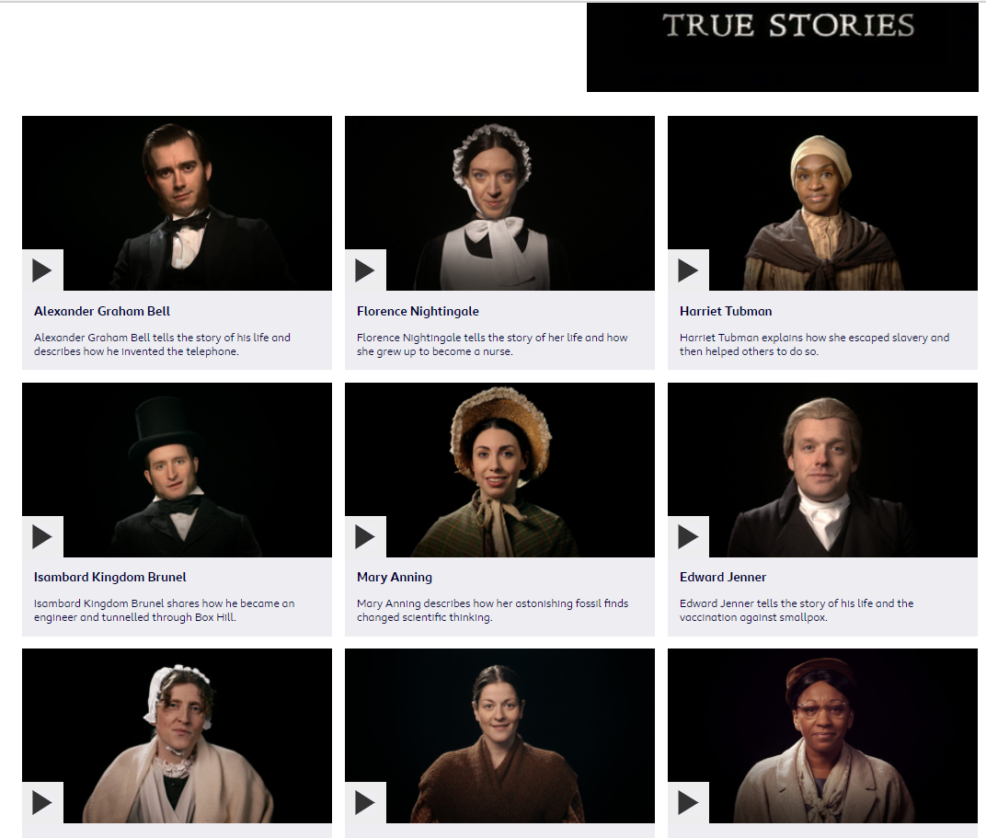

History Home Learning Challenge
Your name
Topic area
Possible question/s
Possible chapters/sections
Resources I can use

History Home Learning Challenge
Your name
Topic area
Possible question/s
Possible chapters/sections
Resources I can use

