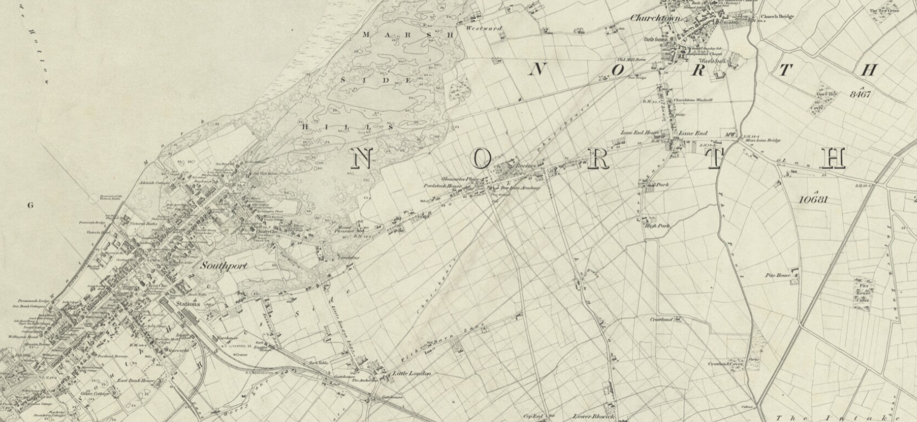
Southport in the 1840s

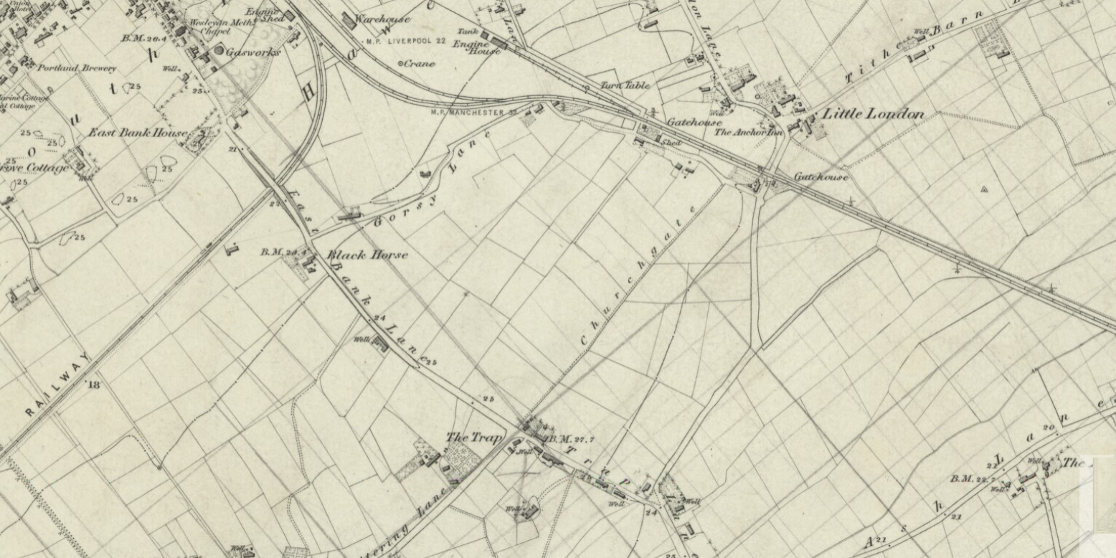
Southport in the 1840s: a close up of the area around the school. There is no Hampton Road at this time!

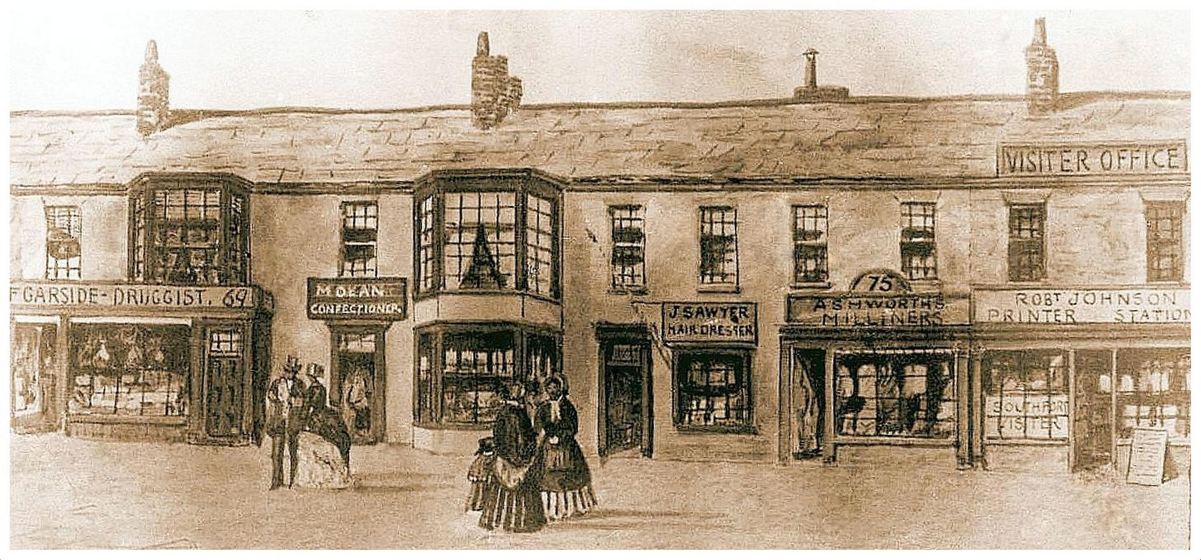
Shops on Lord Street around 1850

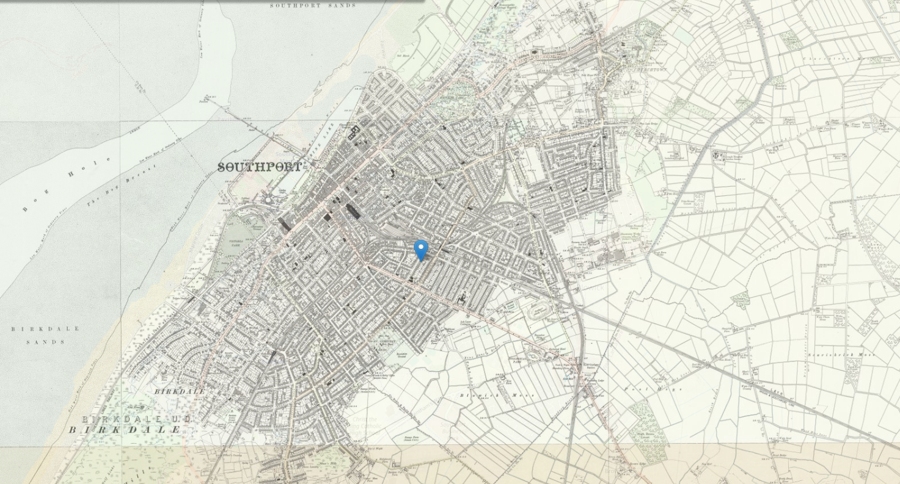
Southport in the 1880s

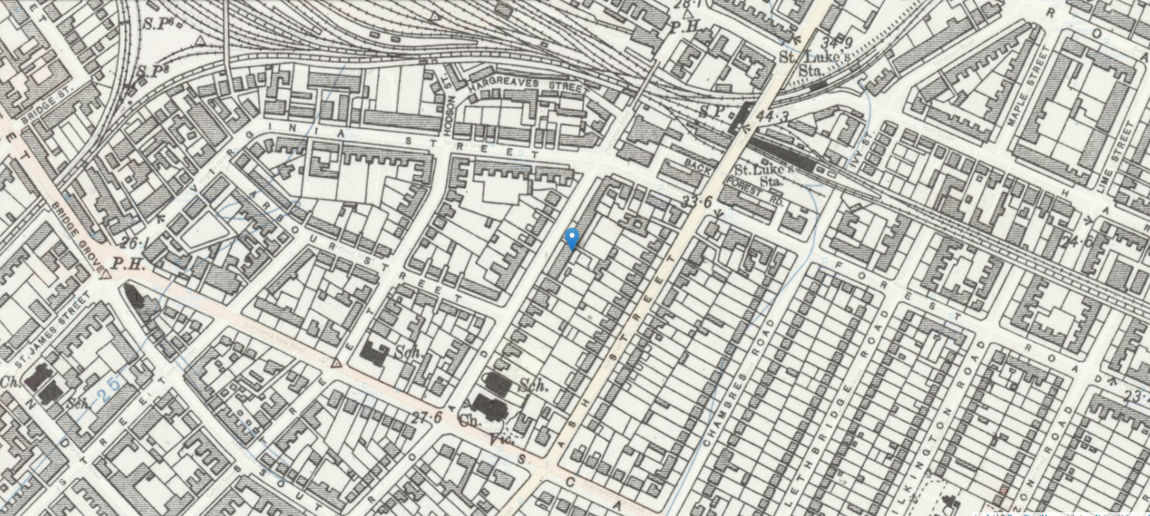
Southport in the 1880s: a close up of the area around the school. The pointer shows where Hampton Road is and the Sch. shows where the school is.

TAKE a look at Southport 175 years ago – a small, refined village.
The dunes lining the famous Southport Sands had been tamed and the town was beginning to expand beyond the elegant Lord Street.
Hamlets such as ‘Little London’ and ‘The Trap’ were prospering whilst the town’s reputation as ‘spa town’ was spreading.
But just 15 years later, Southport was expanding at such a rate that these small communities would be taken over by new streets lined with big Victorian houses.
From a small village of 7,774 in 1841, Southport had 18,076 people in 1871, 32,191 in 1881 and 48,046 at the turn of the 20th century.
LITTLE LONDON & THE ANCHOR INN
Although not mentioned in parish registers until the 18th century, ‘Londehay’ appears as early as 1489 and is now the Rose Hill area of Southport, by Forest Road bridge. Here, merchants from London came to collect the fleeces of wool from North Meols.
At the heart of the hamlet stands The Anchor Inn, now The Blue Anchor pub, where legend has it that pallbearers once stopped to rest when transporting the dead along Little London Lane – from what is now High Park to Duke Street cemetery, then called The Trap. A 6ft slab, three metres off the ground, which once stood outside the pub, is said to have been used by the pallbearers to lay the dead upon while they refreshed themselves.
SETTLEMENTS AROUND SOUTHPORT
The names of the old settlements changed in the mid 1860s to 1870s, as the town of Southport spread its environs and swallowed it up.
Railway Terrace became Railway Street, Snuttering Lane became St Luke’s Road, Gorsey Lane and Trap Lane were replaced by Windsor Road, Boundary Road, Cemetery Road and others.
By 1880, Little London was not being referred to as this name and began to be known as St Luke’s.
THE NILE RIVER
Contrary to popular belief, the river was never anything more than a small stream.
The ‘river’ was perhaps named the Nile in 1798 following Nelson’s victory in Egypt that year.
RICHMOND HILL & ROSE HILL COTTAGES:
In 1845, the town centre site now occupied by civic buildings, such as the library, arts centre and town hall, were two banks of terraced houses known as Richmond Hill and Rose Hill Cottages.

