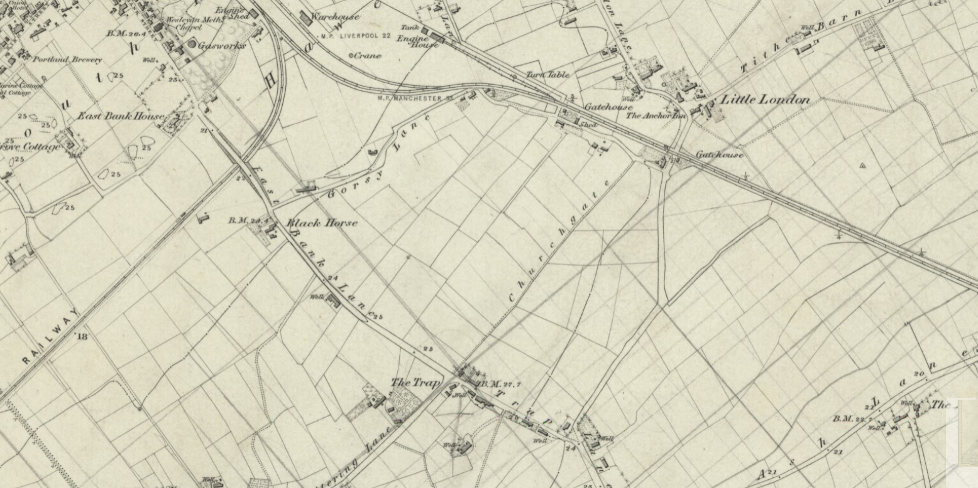
Southport in the 1840s: a close up of the area around the school. There is no Hampton Road at this time!

