Artists Alexander Calder and David Oliveira
LO. To recognise at least two pieces of the artists’ works.
LO. To share something interesting about their work & the artists’ lives.
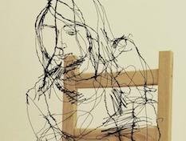 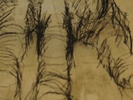 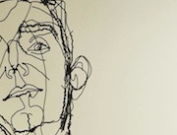 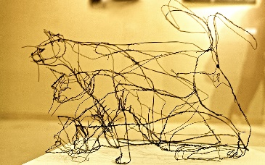 Oliveira 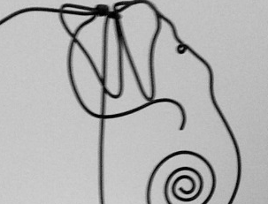 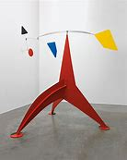 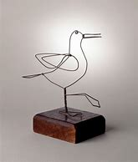 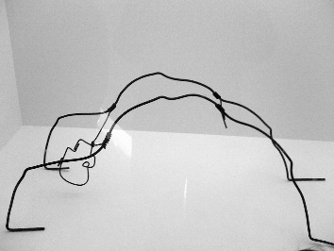 Calder
- Look at the images of works by Oliveira & Calder.
- What can you see in the picture?
- What material is used to create this artwork?
- How do you think it was made?
- Why do you think the artist made it?
- How does the image make you feel?
______________________________________________________________________________________________________
______________________________________________________________________________________________________
______________________________________________________________________________________________________
______________________________________________________________________________________________________
______________________________________________________________________________________________________
______________________________________________________________________________________________________
______________________________________________________________________________________________________
______________________________________________________________________________________________________
______________________________________________________________________________________________________
______________________________________________________________________________________________________
______________________________________________________________________________________________________
______________________________________________________________________________________________________
______________________________________________________________________________________________________

