David Oliveira information sheet
Born in Lisbon 1980.
From a distance, David Oliveira’s wire works look like ink doodles. When you step closer, they still look like ink doodles. This is because David has the ability to make something as rigid and unforgiving as metal wire look like a fluid, if not languid, figure. With both a degree in sculpture and a postgraduate degree in artistic anatomy, a partial explanation of his amazing talent, the 31-year-old artist has been in the circuit for a few years now: he won first prize for sculpture in the Young Artists of Aveiro 2009, the premium revelation D. Fernando in 2010, and is one of the Young Artists selected for the 2011 Lisbon.

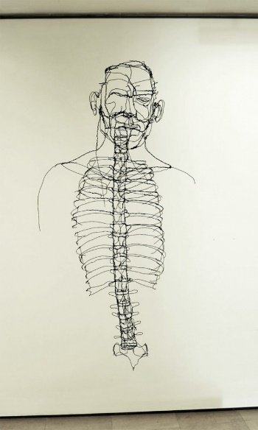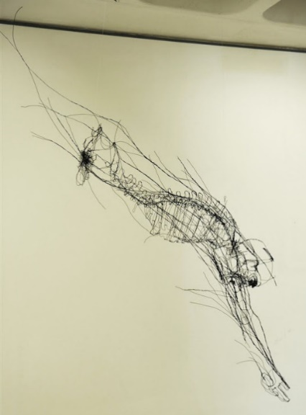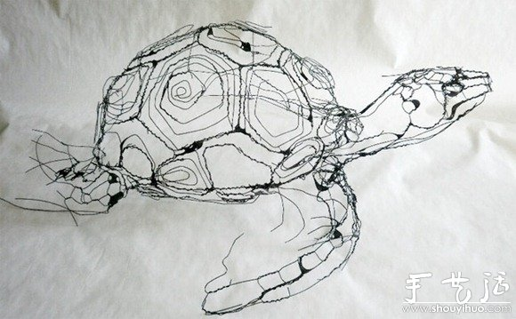

“I Was born in 1980 in Lisbon where I did my academic studies. Got my Degree in Sculpture in 2008, "Faculdade de Belas artes de Lisboa", and returned for an unfinished Masters in- Drawing and compared anatomy.
I started to use the wire to draw in a 3Dimensional space where I could model a shape; any shape. Along with the technique and several works, defined my subject as organic. What made me curious to know all of it. I started looking and peeling to understand what was in each layer. The bone the skin, and the space between.
After I search for the 4th Dimension- Time. This was revealed to me with motion, not the movement but an eternal motion that should always be there and was.
My search made me aware - made look around, and see the lack of respect we, Humans, developed for Nature. The animal exploitation, abuse and slavery, the meat industry, it´s a shame reality of life on Earth in the XXI century. (In Portugal is still allowed to torture bulls in arenas because of the cultural tradition.)
My quest to communicate, made me search the 5th Dimension- Affection. This made me look to Humans again. This is where I stand now.”
David Oliveira 2018

