Alexander Calder information sheet
Alexander Calder was an American sculptor who is best known for his innovative mobiles that embrace chance in their aesthetic and his monumental public sculptures.
Calder came from an artist family. His grandfather and father were both sculptors and his mother a portrait artist. His parents did not want him to be an artist, so he decided to study mechanical engineering. When asked why he decided to study mechanical engineering instead of art Calder said, "I wanted to be an engineer because some guy I rather liked was a mechanical engineer, that's all".
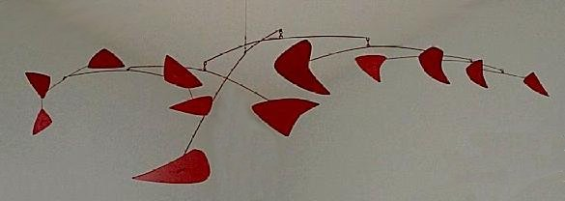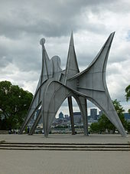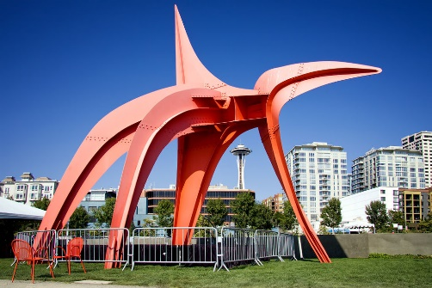
Calder moved to New York and enrolled at the Art Students League. Calder became fascinated with the action of the circus, a theme that would reappear in his later work.
In 1926, Calder moved to Paris, enrolled in the Académie de la Grande Chaumière, and established a studio at 22 rue Daguerre in the Montparnasse Quarter.
Dating from 1931, Calder's sculptures of discrete movable parts powered by motors were christened "mobiles" by Marcel Duchamp, a French pun meaning both "motion" and "motive" However, Calder found that the motorized works sometimes became monotonous in their prescribed movements. His solution, arrived at by 1932, was hanging sculptures that derived their motion from touch or air currents. They were followed in 1934 by outdoor pieces which were set in motion by the open air. The wind mobiles featured abstract shapes delicately balanced on pivoting rods that moved with the slightest current of air, allowing for a freer, more natural, shifting play of forms and spatial relationships.
In 1963, Calder settled into his new workshop, which overlooked the valley of the Lower Chevrière to Saché in Indre-et-Loire (France). He donated to the town a sculpture, which since 1974 has been situated in the town square. Throughout his artistic career, Calder named many of his works in French, regardless of where they were destined for eventual display.

