21.1.22 Homework
Thank you to the parents who attended the phonics screening information sessions this week, it was lovely to see you. If you didn’t manage to make it, I have put an information PowerPoint on the website.

Our topic this half term is London.
For homework this week, please can you help your children to find some facts about any of the London landmarks below.
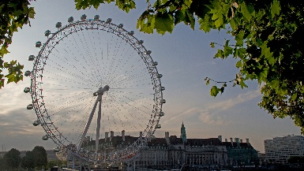
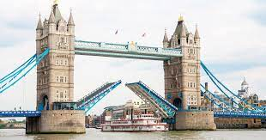
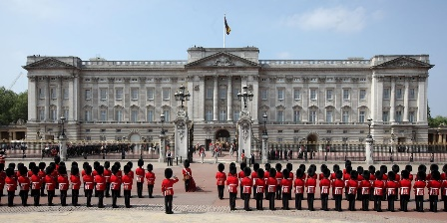
Buckingham The London Tower Bridge Palace Eye

We will be using some of the facts in their writing next week.
If your child is struggling to write themselves please write for them. Thank you.
21.1.22 Homework
Our topic this half term is London.
For homework this week, please can you help your children to find some facts about any of the London landmarks below.
Buckingham The London Tower Bridge Palace Eye

We will be using some of the facts in their writing next week.
If your child is struggling to write themselves please write for them. Thank you.

