26.11.21 Homework
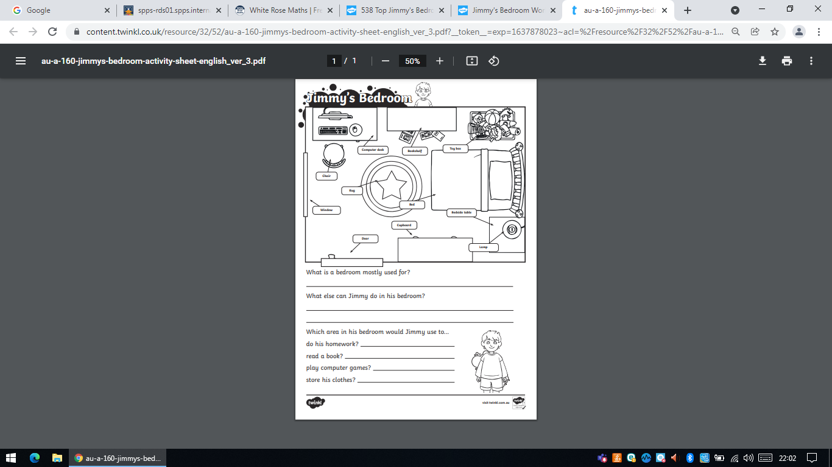
This half term, in Geography, we are learning how to draw maps. The children need to look at the bird’s-eye-view of Jimmy’s bedroom and answer the questions.

Nest week we will be testing the children on the following spellings as they work towards achieving their bronze spelling badges.
the a to do today was
of said says are were

