Year 1 news Thank you so much for sending aprons into school, we really appreciate your support. 9.10.20
Thank you everyone for your patience on Wednesday during parent’s evening. It was lovely to speak to you all. This week we have been writing about baby dinosaur’s day out. All your children are becoming super writers. We have been beginning to learn about addition in maths and will be continuing this next week.

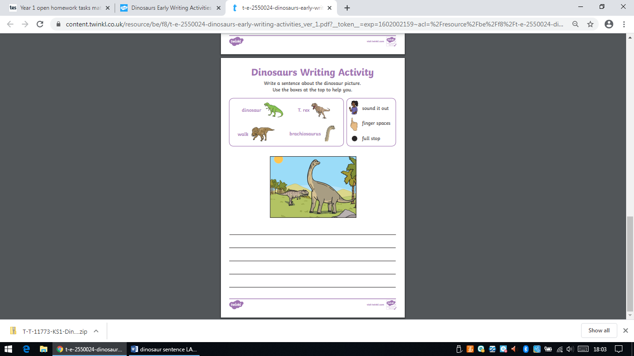

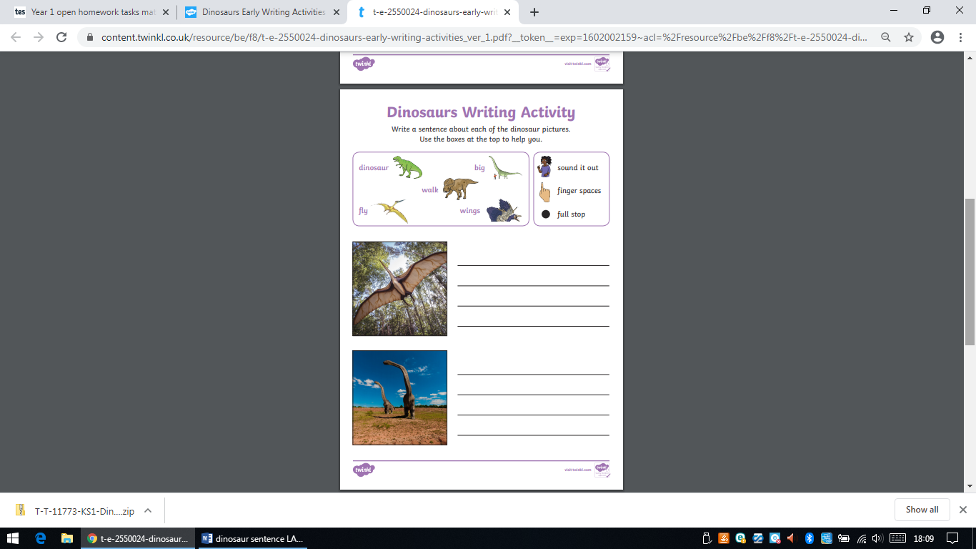
Can you write about the dinosaur pictures?

