8/10/21
This week we have been learning the sounds ‘i, n, m, d’. Practice the actions and complete the activities for each sound.
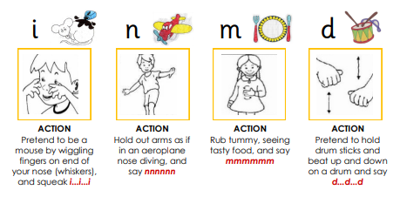

8/10/21
This week we have been learning the sounds ‘i, n, m, d’. Practice the actions and complete the activities for each sound.

