15/10/21
This week we have been learning the sounds ‘g, o, c, k’. Practice the actions and complete the activities for each sound.
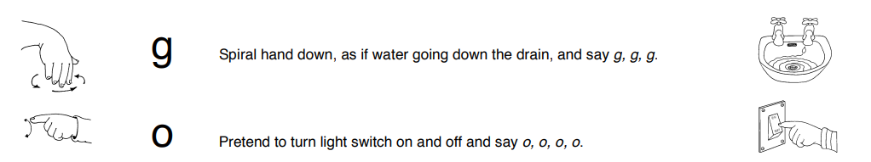
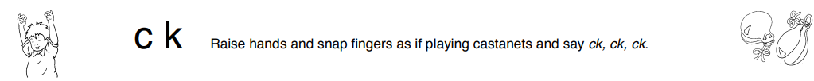

15/10/21
This week we have been learning the sounds ‘g, o, c, k’. Practice the actions and complete the activities for each sound.

