22/10/21
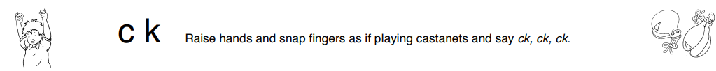
This week we have been learning the sounds ‘ck, e, u, r’. And tricky words ‘the’ and ‘to’. Practice the actions and complete the activities for each sound.

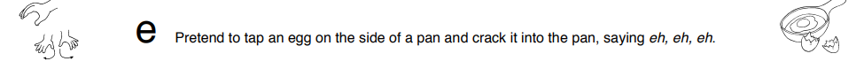

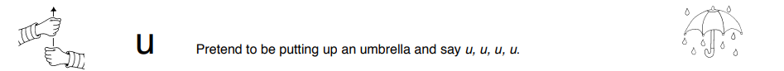

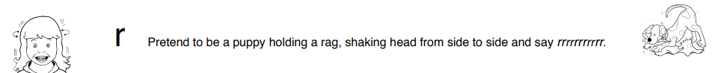

22/10/21
This week we have been learning the sounds ‘ck, e, u, r’. And tricky words ‘the’ and ‘to’. Practice the actions and complete the activities for each sound.

