5/11/21
This week we have been learning the sounds ‘h, b, f/ff, l/ll’. Practice the actions and complete the activities for each sound.
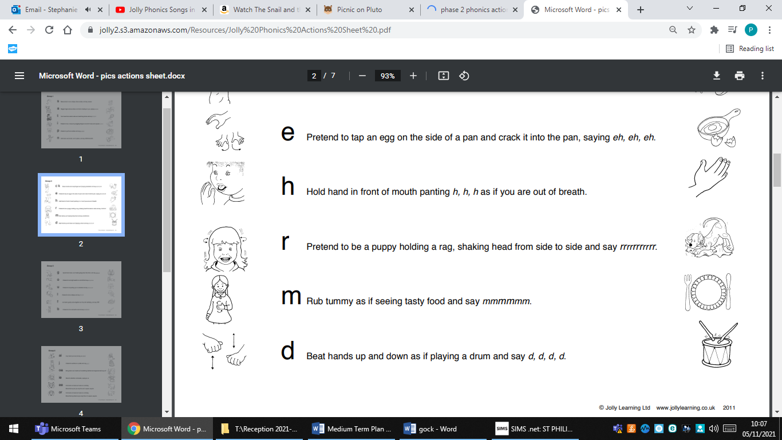

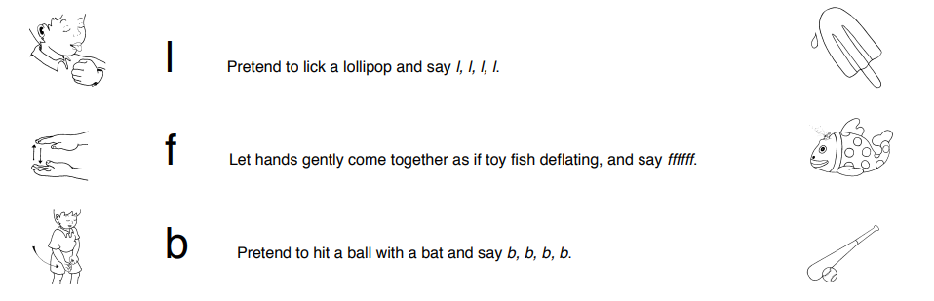

5/11/21

5/11/21
This week we have been learning the sounds ‘h, b, f/ff, l/ll’. Practice the actions and complete the activities for each sound.

