Set: Friday 25th Feb Homework due in by: 2nd March
This week…
- We have started our non-chronological reports for RE about Communion.
- We have looked at examples of balanced arguments in English

Next week: WORLD BOOK DAY- Thurs 3rd March
- We will be writing our balanced arguments about social media
- We will be continuing to look at measures in Maths

Reading: It is important that you read frequently throughout the week- at least three times. Please record in your reading record.
Spellings:

At least half a page in your homework books please! Week 2- Word families
*IDL children- please do at least 15 minutes of IDL practise – English and Maths!

English- Should primary school aged children be allowed on social media? Collect your families views to include in your writing next week! Collect any extra facts/statistics to help with your writing.

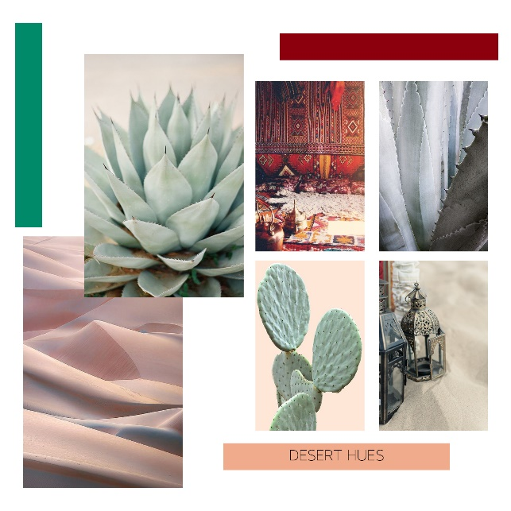
Art : Find out about desert animals and flowers – create a ‘mood’ board of the colours you might find in the desert and collage any pictures you print off…for example…. Use a page of your homework book for this- or you can create it on the computer and print off. Add words to describe…
Don’t forget! World Book Day is on Thursday March 3rd – our theme is Harry Potter. Have you got something you can wear? Have you got anything to help create our Harry Potter themed reading area? Please get hunting!

